CONTENTS

Worship
Word
Works
Upcoming:
Preaching Schedule
Event Highlights
Equip courses

WORSHIP (Praise and Prayer)

- Malaysia
Pray for:
- Nation
  - Pray against radical religious ideology, against groups who would use religious sentiment to advance their political agenda.
  - Pray for boldness and prudence amid the ruling Government to deal with extremism.
  - Ask God for Divine protection over Malaysia – over our communities and nations. May God encamp all in a hedge of protection to ward us in all our ways.
- Parliament
  - Pray for members of Parliament –for righteous law-making and godly government to steer the country through the global shaking of economies and politics.
- Church
  - Pray that Christian leaders will speak out against transgressions but with humility and love against any deceit and animosity.

- Japan – Death Toll rising in Typhoon Hagibis aftermath
15 Oct: Typhoon Hagibis ravaged the nation over the weekend, with the death toll amounting 66. Prime Minister Shinzo Abe cites plans to designate Typhoon Hagibis a "severe natural disaster," so as to boost state subsidies for restoration work in affected regions. (Source: NHK)
Pray:
- The evacuees
  - God’s comfort for those who lost their loved ones; solace for the wounded; families to be reunited.
  - That adequate necessities will be distributed.
  - Wisdom & discernment by respective authorities to proceed smoothly.
  - Pray too, for strength for relief and aid workers.
- Churches
  - That pastors would be wise and persevere as they serve their congregations and communities.
  - That acts of compassion would soften the hearts of those in need to respond to the gospel.
  - That spiritual awakening would take place across Japan.

WORD (60 minutes)

Step Forward to live Meaningfully & Fruitfully
(Genesis 39:1-10)
Dato’ Dr. Daniel Ho, Founding Senior Pastor

- Read the scripture passage.
- Do a THREE-MINUTE SUMMARY of the sermon highlighting the KEY POINTS. Do not preach the whole sermon, as majority of your members would have heard the sermon already. Allocate more time for sharing in the cell through the application questions below.
- Sermon Resource at: http://www.dumc.my/resources/sermons/

Reflection & Application Questions:

- Share an example of dysfunction, abuse, hurt or pain in your life. How did you handle it? What would you have done or not done today?

- How have you helped someone who has or is going through dysfunction or pain in life? What have been the results? What did you learn through this experience and what advice or help could you give?

- How can you ensure that you live a meaningful, effective and fruitful life throughout?

Note to Word facilitator:
As you are preparing for this session, this is a great time to pray that the Holy Spirit will guide you to use the questions efficaciously. You can select, modify or entirely create your own questions, according to the needs of your CG, especially if you feel that there are too many questions than required for the allocated time.

Note to Cell Groups that have children during meeting:
We recognise several cell groups in DUMC may have 5 or more children joining them during Cell Group meetings. We would like to get them engaged as well during the session therefore we are suggesting for CGs to use Manna Pad and assign someone in rotation to facilitate them after worship. Here is the link to the Manna Pad materials http://dumc.my/resources/downloads/

WORKS (Ministry and Bearing Witness)

Cell leaders to ask these two important questions or share with one another during Works session in every CG meeting.

    - Who have I met, praying for and sharing Christ with?
    - What is the Holy Spirit saying about the community I am in?

- Share Your Story (Your Story, His Glory)
- Whether your story is about how you came to know Christ, illness healed, an act of kindness in your times of need, or of how you served people or how people have served you, give glory to God. Share your story so that people will be encouraged and God's love is known.
- If there are any good testimonies, ask your members to write out their testimonies and submit to the church: http://dumc.my/connect/individual-care/share-your-story/

- Personal: Bible Reading and Journaling
- Subscribe to the Bible Reading Plan app: YouVersion – OwnIt365 New Testament (NT)+ Plan.
- Request one of your members to share a journal entry. Pair up members to share with, and pray for one another.

- Scripture Memory
Every cell meeting, do get your cell members to recite the following together:

Galatians 5:25 (Theme verse for 2019)
Since we live by the Spirit, let us keep in step with the Spirit.

Galatians 2:20 (added from March 2019)
I have been crucified with Christ and I no longer live, but Christ lives in me. The life I now live in the body, I live by faith in the Son of God, who loved me and gave himself for me.

- CrossFields
Crossing into the harvest field with the message of the Cross.

Sarawak Penan | 30 Nov-6 Dec
Sarawak Iban | 11-18 Dec
Myanmar | 4-11 Nov
Cambodia | 14-22 Nov
Vietnam | 5 - 10 Dec
Nepal | 5-15 Dec

MCPP1 | 19 - 20 Oct | Empress Hotel (Sepang)

Website: dumc.my/missions
Mission trip dates: bit.ly/CF2019cal

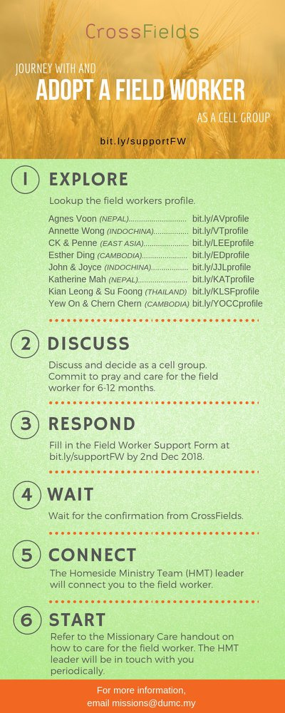

- CMS: Steps to Fill in the Salvation Form
- Select “More”
- “Form”
- Select “Form List” box
- Look for “Salvation Form”
- Fill in form of new salvation by “Change Respondent”
- Must have “E-mail” and “Mobile Phone”

UPCOMING

PREACHING SCHEDULE

26 & 27 Oct | Stepping Forward | Pr Chris M
2 & 3 Nov | Mission Heart of God 1 | Pr Kelvin Yong
9 & 10 Nov | Mission Heart of God 2 | Ross Winchester
16 & 17 Nov | Mission Heart of God 3 | Pr Datuk Kee Sue Sing

Go to: http://www.dumc.my/resources/sermons/ for the latest info.
EVENT HIGHLIGHTS

  - Join The Celebrations in DUMC@Puchong at 10am Every Sunday
Bring your friends and family members living around the Puchong area. Look for DUMC@Puchong on Waze or Google Maps. (Please park at IOI Business Park Level B2)

  - CHRISTMAS CAROLLING
“Sing to the Lord, for he has done glorious things; let this be known to all the world.” Isaiah 12:5. In this Christmas season, share the truth of God's grace through the beautiful tunes of Christmas carols. Therefore, come join us for this year's Christmas Carolling! We are recruiting everyone who is interested or loves to carol.
Sign up at bit.ly/carolling2019dumc by November 3rd.

  - W2W ENCOUNTER
22-24 Nov | Grand Kampar Hotel A weekend getaway specially for women. Early bird registration opens next week.
Register at bit.ly/ew-nov19 or Info Counter!

  - CHURCH PRAYER ALTAR
Every Saturday | 7.00 -9.00am | Room 101 & 102
Let us come and seek the face of God. Prayer precedes everything.

  - WANT TO JOIN THE DUMC FAMILY?
Here are the steps:
> Join a Cell Group (You can get help at our CG Kiosk)
> Attend Basic Christianity 101
> Attend DUMC 101
> Join an Encounter Weekend
> Baptism & Membership Interview Sign up at the Info Counter or online at dumc.my/equip

  - IMPACT
2020·YOU·ME·theNATIONS
DUMC is turning 40 in 2020! It’s time to look outwards — beyond the four walls of our church. Info? Visit the IMPACT info booth or go to bit.ly/IMPACTleaflet

  - TUESDAY ENCOUNTER NIGHT (3rd & 4th Tuesdays of every month)
15 Oct | 8.30pm-10.00pm | Hall 3, DC
22 Oct | 8.30pm-10.00pm | DUMC@Puchong
Come together and be refreshed by His presence.
Info? Contact forerunners@dumc.my

EQUIP COURSES 2019

PRAYER 101
Sundays | 22 Sep-17 Nov | 8.00am-9.45am

SPIRITUAL RETREAT: RHYTHM OF GRACE
Thursday to Sunday | 31 Oct-3 Nov Register via: bit.ly/SROct2019

BMEW (Note: Membership Requirement)
Weekend Away | 19-20 Oct | Empress Hotel

BIBLE 101
Saturdays | 16 & 23 Nov | 8.30am-1.00pm

LIBRARY HOURS
Saturdays | 1.30pm-4.45pm
Sundays | 9.30am-1.30pm
Weekdays | CLOSED
Find out more about Equip courses at the Info Counter in Concourse 2, or online at http://dumc.my/equip

