CONTENTS

Worship
Word
Works
Upcoming:
Preaching Schedule
Event Highlights
Equip courses

WORSHIP (Praise and Prayer)

- Malaysia
Pray for:
- Children
  - The protection of children – including stateless and refugees – through improved laws, policies and practices so that they can grow in a safe, secure, healthy and loving environment.
  - Children with special needs are well cared for.

- International Day of Prayer for the Persecuted
This November, millions of Christians worldwide will unite for one cause: to join the global Body of Christ for the 2019 International Day of Prayer for the Persecuted (IDOP). The number one thing persecuted Christians ask for is prayer. ‘Let us be on the side of those who sit in jails and are sentenced to death for their faith. Let us pray for them and help them’. (Richard Wurmbrand ‘Reaching towards the heights’)

Uzbekistan
Uzbekistan is a country located in Central Asia. Ranked No. 17 on Open Doors – World Watch List, Uzbekistan has high levels of persecution. Any religious activity not controlled or run by the government is banned in the country. Pray:
- For protection and courage for Christian converts facing extreme persecution.
- For God’s comfort and care over isolated and excluded Christian converts.
- That Uzbek Christians will continue to be faithful and rejoice in God.

WORD (60 minutes)

The Mission Heart of God series:
For His Glory (Romans 10:11-15)
Pastor Kelvin Yong
BIG IDEA: Missions is about the pursuit of God’s glory among the nations

- Read the scripture passage.
- Do a THREE-MINUTE SUMMARY of the sermon highlighting the KEY POINTS. Do not preach the whole sermon, as majority of your members would have heard the sermon already. Allocate more time for sharing in the cell through the application questions below.
- Sermon Resource at: http://www.dumc.my/resources/sermons/

Reflection & Application Questions:

- What does “the pursuit of God’s glory among the nations” mean to you? How can you be involved in God’s strategic plan to fulfil this mission?

- What is one “lion” that you want to chase in the coming year? What are some of your constraints or concerns?

- What is one IMPACT2020 project your cell group can undertake together in response to Christ’s mandate?

Note to Word facilitator:
As you are preparing for this session, this is a great time to pray that the Holy Spirit will guide you to use the questions efficaciously. You can select, modify or entirely create your own questions, according to the needs of your CG, especially if you feel that there are too many questions than required for the allocated time.

Note to Cell Groups that have children during meeting:
We recognise several cell groups in DUMC may have 5 or more children joining them during Cell Group meetings. We would like to get them engaged as well during the session therefore we are suggesting for CGs to use Manna Pad and assign someone in rotation to facilitate them after worship. Here is the link to the Manna Pad materials http://dumc.my/resources/downloads/

WORKS (Ministry and Bearing Witness)

Cell leaders to ask these two important questions or share with one another during Works session in every CG meeting.

    - Who have I met, praying for and sharing Christ with?
    - What is the Holy Spirit saying about the community I am in?

- Share Your Story (Your Story, His Glory)
- Whether your story is about how you came to know Christ, illness healed, an act of kindness in your times of need, or of how you served people or how people have served you, give glory to God. Share your story so that people will be encouraged and God's love is known.
- If there are any good testimonies, ask your members to write out their testimonies and submit to the church: http://dumc.my/connect/individual-care/share-your-story/

- Personal: Bible Reading and Journaling
- Subscribe to the Bible Reading Plan app: YouVersion – OwnIt365 New Testament (NT)+ Plan.
- Request one of your members to share a journal entry. Pair up members to share with, and pray for one another.

- Scripture Memory
Every cell meeting, do get your cell members to recite the following together:

Galatians 5:25 (Theme verse for 2019)
Since we live by the Spirit, let us keep in step with the Spirit.

Galatians 2:20 (added from March 2019)
I have been crucified with Christ and I no longer live, but Christ lives in me. The life I now live in the body, I live by faith in the Son of God, who loved me and gave himself for me.

- CrossFields
Crossing into the harvest field with the message of the Cross.

Myanmar | 4-11 Nov
Cambodia | 14-22 Nov
Vietnam | 5 - 10 Dec
Nepal | 5-15 Dec
Sarawak Iban | 11-18 Dec

Website: dumc.my/missions
Mission trip dates: bit.ly/CF2019cal

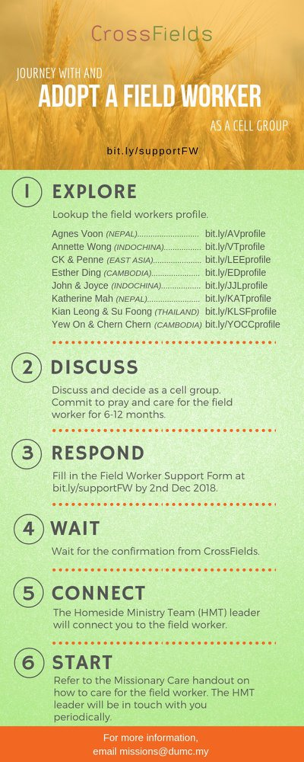

- CMS: Steps to Fill in the Salvation Form
- Select “More”
- “Form”
- Select “Form List” box
- Look for “Salvation Form”
- Fill in form of new salvation by “Change Respondent”
- Must have “E-mail” and “Mobile Phone”

UPCOMING

PREACHING SCHEDULE

2 & 3 Nov | Mission Heart of God 1 | Pr Kelvin Yong
9 & 10 Nov | Mission Heart of God 2 | Ross Winchester
16 & 17 Nov | Mission Heart of God 3 | Pr Datuk Kee Sue Sing
23 & 24 Nov | Mission Heart of God 4 | Datuk Dennis Ignatius

Go to: http://www.dumc.my/resources/sermons/ for the latest info.

EVENT HIGHLIGHTS

  - Join The Celebrations in DUMC@Puchong at 10am Every Sunday
Bring your friends and family members living around the Puchong area. Look for DUMC@Puchong on Waze or Google Maps. (Please park at IOI Business Park Level B2)

  - After7
Our After7 Talks happening this November 9th is specially designed to upskill individuals and CGs to host Christmas dinner parties for their friends and family! Learn how to prepare a delicious and wholesome dish while also upskilling on setting a dining table for guests properly, with guest speakers Su Mene and Cynthia.

  - CHRISTMAS CAROLLING
“Sing to the Lord, for he has done glorious things; let this be known to all the world.” Isaiah 12:5. In this Christmas season, share the truth of God's grace through the beautiful tunes of Christmas carols. Therefore, come join us for this year's Christmas Carolling! We are recruiting everyone who is interested or loves to carol.
Sign up at bit.ly/carolling2019dumc by November 3rd.

  - W2W ENCOUNTER
22-24 Nov | Grand Kampar Hotel A weekend getaway specially for women.
Register at bit.ly/ew-nov19 or Info Counter!

  - CHURCH PRAYER ALTAR
Every Saturday | 7.00 -9.00am | Room 101 & 102
Let us come and seek the face of God. Prayer precedes everything.

  - TUESDAY ENCOUNTER NIGHT (3rd & 4th Tuesdays of every month)
19 Nov | 8.30pm-10.00pm | Hall 3, DC
26 Nov | 8.30pm-10.00pm | DUMC@Puchong
Come together and be refreshed by His presence.
Info? Contact forerunners@dumc.my

  - WANT TO JOIN THE DUMC FAMILY?
Here are the steps:
> Join a Cell Group (You can get help at our CG Kiosk)
> Attend Basic Christianity 101
> Attend DUMC 101
> Join an Encounter Weekend
> Baptism & Membership Interview
Sign up at the Info Counter or online at dumc.my/equip

  - IMPACT
2020·YOU·ME·theNATIONS
DUMC is turning 40 in 2020! It’s time to look outwards — beyond the four walls of our church. Info? Visit the IMPACT info booth or go to bit.ly/IMPACTleaflet

EQUIP COURSES 2019

CHRISTIAN LEADERSHIP 301
Saturdays | 16 & 23 Nov | 8.30am-1.00pm

BIBLE 101
Saturdays | 16 & 23 Nov | 8.30am-1.00pm

SPIRITUAL WARFARE 201
Saturdays | 16 & 30 Nov | 8.30am-1.00pm

EVANGELISM 101 (Note: Membership Requirement)
Saturday | 30 Nov | 8.30am-1.00pm

PAUSE AND PONDER (Year-end Prayer and Reflection)
Saturday | 7 Dec | 8.30am-11.30am Register via: bit.ly/PPDec2019

ALPHA PREVIEW Food. Talk. Discussion.
Sunday | 23 Feb 2020 | 12.30pm-2.30pm

LIBRARY HOURS: CLOSED for renovation until further notice

Find out more about Equip courses at the Info Counter in Concourse 2, or online at http://dumc.my/equip

