CONTENTS

Worship
Word
Works
Upcoming:
Preaching Schedule
Event Highlights
Equip courses

WORSHIP (Praise and Prayer)

- Malaysia – Church: Confession & Repentance
Ask the Lord for His forgiveness for we have lost our FIRST LOVE. Pray for these:
- We have shown in our daily lifestyles that we do not seek first God’s kingdom and His righteousness, although we preach, talk and sing about His kingdom.
- We have lost our First love. Our hearts are increasingly indifferent toward Him, His name, and His work. We love ourselves more than we love God. We spend a lot more time on our smartphones and digital media than with God. We have not lived holy lives, and too easy with sin. We have no love for the Word of God, nor obey it either.
- We cry for revival in our land and in our churches but we are too tired to go for prayer meetings.

- International Day of Prayer for the Persecuted - Nigeria
Christians face extreme levels of persecution by Islamist extremists regularly. The Boko Haram, a terrorist group and Fulani herdsmen are the main perpetrators of violence against Christians.
Pray for:
- God would strengthen the persecuted church in Nigeria.
- God would protect the increasingly oppressed Christians in the country.
- The leaders of Nigeria will take decisive actions to end the persistent attacks on Christians.

WORD (60 minutes)

The Mission Heart of God series:
For the People There (1 Samuel 22:1-2; Psalm 57)
Pastor Ross Winchester, Mandate Ministries

BIG IDEA: Effective missions is about identification, influence and impact

- Read the scripture passage.
- Do a THREE-MINUTE SUMMARY of the sermon highlighting the KEY POINTS. Do not preach the whole sermon, as majority of your members would have heard the sermon already. Allocate more time for sharing in the cell through the application questions below.
- Sermon Resource at: http://www.dumc.my/resources/sermons/

Reflection & Application Questions:

- Who are those who joined David when he was at the cave of Adullam? Why were those there considered to have a ‘cave’ (vs. community) mentality?

- What is the difference between the unsaved vs. unreached? Can you share a personal experience of yours in reaching either the unsaved or the unreached? From there, can you highlight the similarities and differences in reaching both of these groups of persons?

- Which of the three ‘Fishing Philosophies’ impacted you the most and why? How will it influence you to reach out to others with the Gospel of Jesus Christ?

- Quote from Howard Snyder: “Church people think about how to get people into church; kingdom people think about how to get the church into the world. Church people worry that the world might change the church; Kingdom people work to see the church changes the world.”

From this statement above, how does it impact your life to witness to the world? How would you modify your life and thinking to impact others?

Note to Word facilitator:
As you are preparing for this session, this is a great time to pray that the Holy Spirit will guide you to use the questions efficaciously. You can select, modify or entirely create your own questions, according to the needs of your CG, especially if you feel that there are too many questions than required for the allocated time.

Note to Cell Groups that have children during meeting:
We recognise several cell groups in DUMC may have 5 or more children joining them during Cell Group meetings. We would like to get them engaged as well during the session therefore we are suggesting for CGs to use Manna Pad and assign someone in rotation to facilitate them after worship. Here is the link to the Manna Pad materials http://dumc.my/resources/downloads/

WORKS (Ministry and Bearing Witness)

Cell leaders to ask these two important questions or share with one another during Works session in every CG meeting.

    - Who have I met, praying for and sharing Christ with?
    - What is the Holy Spirit saying about the community I am in?

- Share Your Story (Your Story, His Glory)
- Whether your story is about how you came to know Christ, illness healed, an act of kindness in your times of need, or of how you served people or how people have served you, give glory to God. Share your story so that people will be encouraged and God's love is known.
- If there are any good testimonies, ask your members to write out their testimonies and submit to the church: http://dumc.my/connect/individual-care/share-your-story/

- Personal: Bible Reading and Journaling
- Subscribe to the Bible Reading Plan app: YouVersion – OwnIt365 New Testament (NT)+ Plan.
- Request one of your members to share a journal entry. Pair up members to share with, and pray for one another.

- Scripture Memory
Every cell meeting, do get your cell members to recite the following together:

Galatians 5:25 (Theme verse for 2019)
Since we live by the Spirit, let us keep in step with the Spirit.

Galatians 2:20 (added from March 2019)
I have been crucified with Christ and I no longer live, but Christ lives in me. The life I now live in the body, I live by faith in the Son of God, who loved me and gave himself for me.

- CrossFields
Crossing into the harvest field with the message of the Cross.

Cambodia | 14-22 Nov
Sarawak Penan | 30 Nov - 6 Dec
Vietnam | 5 - 10 Dec
Nepal | 5-15 Dec
Sarawak Iban | 11-18 Dec

Website: dumc.my/missions
Mission trip dates: bit.ly/CF2019cal

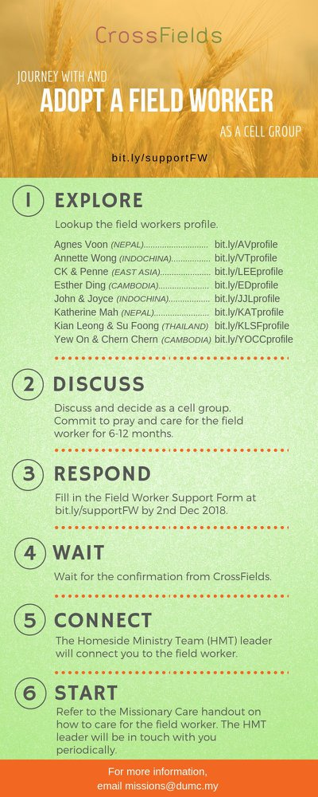

- CMS: Steps to Fill in the Salvation Form
- Select “More”
- “Form”
- Select “Form List” box
- Look for “Salvation Form”
- Fill in form of new salvation by “Change Respondent”
- Must have “E-mail” and “Mobile Phone”

UPCOMING

PREACHING SCHEDULE

16 & 17 Nov | Mission Heart of God 3 | Pr Datuk Kee Sue Sing
23 & 24 Nov | Mission Heart of God 4 | Datuk Dennis Ignatius

Go to: http://www.dumc.my/resources/sermons/ for the latest info.

EVENT HIGHLIGHTS

  - Join The Celebrations in DUMC@Puchong at 10am Every Sunday
Bring your friends and family members living around the Puchong area. Look for DUMC@Puchong on Waze or Google Maps. (Please park at IOI Business Park Level B2)

  - CHRISTMAS CAROLLING
“Sing to the Lord, for he has done glorious things; let this be known to all the world.” Isaiah 12:5. In this Christmas season, share the truth of God's grace through the beautiful tunes of Christmas carols. Therefore, come join us for this year's Christmas Carolling! We are recruiting everyone who is interested or loves to carol.
Sign up at bit.ly/carolling2019dumc by November 3rd.

  - W2W ENCOUNTER
22-24 Nov | Grand Kampar Hotel A weekend getaway specially for women.
Register at bit.ly/ew-nov19 or Info Counter!

  - CHURCH PRAYER ALTAR
Every Saturday | 7.00 -9.00am | Room 101 & 102
Let us come and seek the face of God. Prayer precedes everything.

  - TUESDAY ENCOUNTER NIGHT (3rd & 4th Tuesdays of every month)
19 Nov | 8.30pm-10.00pm | Hall 3, DC
26 Nov | 8.30pm-10.00pm | DUMC@Puchong
Come together and be refreshed by His presence.
Info? Contact forerunners@dumc.my

  - WANT TO JOIN THE DUMC FAMILY?
Here are the steps:
> Join a Cell Group (You can get help at our CG Kiosk)
> Attend Basic Christianity 101
> Attend DUMC 101
> Join an Encounter Weekend
> Baptism & Membership Interview
Sign up at the Info Counter or online at dumc.my/equip

  - IMPACT
2020·YOU·ME·theNATIONS
DUMC is turning 40 in 2020! It’s time to look outwards — beyond the four walls of our church. Info? Visit the IMPACT info booth or go to bit.ly/IMPACT2020DUMC

EQUIP COURSES 2019

CHRISTIAN LEADERSHIP 301
Saturdays | 16 & 23 Nov | 8.30am-1.00pm

BIBLE 101
Saturdays | 16 & 23 Nov | 8.30am-1.00pm

SPIRITUAL WARFARE 201
Saturdays | 16 & 30 Nov | 8.30am-1.00pm

EVANGELISM 101 (Note: Membership Requirement)
Saturday | 30 Nov | 8.30am-1.00pm

PAUSE AND PONDER (Year-end Prayer and Reflection)
Saturday | 7 Dec | 8.30am-11.30am Register via: bit.ly/PPDec2019

ALPHA PREVIEW Food. Talk. Discussion.
Sunday | 23 Feb 2020 | 12.30pm-2.30pm

LIBRARY HOURS: CLOSED for renovation until further notice

Find out more about Equip courses at the Info Counter in Concourse 2, or online at http://dumc.my/equip

