CONTENTS

Worship
Word
Works
Upcoming:
Preaching Schedule
Event Highlights
Equip courses

WORSHIP (Praise and Prayer)

- Malaysia – Leaders
Pray for:
- Well-being of senior civil servants, judges and lawmakers that they will execute God’s righteousness fearlessly.
- God’s kingdom to come, for the mighty wind of the Holy Spirit, to bring salvation and peace into the hearts of men.
- The nation’s churches that they will pray and labour for genuine spiritual revival both in the church and the nation.

- International Day of Prayer for the Persecuted – Uganda
Majority of the population in Uganda consists of Christians. However, Christian persecution prevails in areas densely populated with Muslims.

Pray:
- God would embolden Christians to stand firm in the faith notwithstanding the oppressions they face.
- Greater religious freedoms in the country
- Government will exercise authority justly and not discriminate Christians.

WORD (60 minutes)

The Mission Heart of God series:
Stand on the Hill (Exodus 4:2, 17:8-13)
Dato’ Dennis Ignatius

BIG IDEA #1: Not about who you are, but about who He is
BIG IDEA #2: God has put seeds of greatness within you (2 Tim 1:6)
BIG IDEA #3: God didn’t call you to sit in church, but to stand on the hill

- Read the scripture passage.
- Do a THREE-MINUTE SUMMARY of the sermon highlighting the KEY POINTS. Do not preach the whole sermon, as majority of your members would have heard the sermon already. Allocate more time for sharing in the cell through the application questions below.
- Sermon Resource at: http://www.dumc.my/resources/sermons/

Reflection & Application Questions:

- Read Exodus 3:10. How different was Moses and you? Why would you think that way? What is stopping you from being the “Man” whom God would choose to accomplish His will?

- What is the “Staff” that is already in your hand? List out your giftings, especially those you may recently discover through IMPACT Academy. Are these hidden or publicly displayed to bless others? How can these be further honed for 2020 and beyond?

- We are blessed with many ‘Horeb’, personal encounters with the Lord but He is now calling us to another “Hill”, i.e. Rephidim to face the giants. It is time not just to believe it, but to preach it, practice it and live it! What is the “Hill” that God is calling you to stand on, the “lion” that he wants you to chase? Are you willing to pay the cost of standing on the hill for His glory?

Note to Word facilitator:
As you are preparing for this session, this is a great time to pray that the Holy Spirit will guide you to use the questions efficaciously. You can select, modify or entirely create your own questions, according to the needs of your CG, especially if you feel that there are too many questions than required for the allocated time.

Note to Cell Groups that have children during meeting:
We recognise several cell groups in DUMC may have 5 or more children joining them during Cell Group meetings. We would like to get them engaged as well during the session therefore we are suggesting for CGs to use Manna Pad and assign someone in rotation to facilitate them after worship. Here is the link to the Manna Pad materials http://dumc.my/resources/downloads/

WORKS (Ministry and Bearing Witness)

Cell leaders to ask these two important questions or share with one another during Works session in every CG meeting.

    - Who have I met, praying for and sharing Christ with?
    - What is the Holy Spirit saying about the community I am in?

- Share Your Story (Your Story, His Glory)
- Whether your story is about how you came to know Christ, illness healed, an act of kindness in your times of need, or of how you served people or how people have served you, give glory to God. Share your story so that people will be encouraged and God's love is known.
- If there are any good testimonies, ask your members to write out their testimonies and submit to the church: http://dumc.my/connect/individual-care/share-your-story/

- Personal: Bible Reading and Journaling
- Subscribe to the app: YouVersion – OwnIt365 New Testament (NT)+ Plan.
- Request one of your members to share a journal entry. Pair up members to share with, and pray for one another.

- Scripture Memory
Every cell meeting, do get your cell members to recite the following together:

Galatians 5:25 (Theme verse for 2019)
Since we live by the Spirit, let us keep in step with the Spirit.

Galatians 2:20 (added from March 2019)
I have been crucified with Christ and I no longer live, but Christ lives in me. The life I now live in the body, I live by faith in the Son of God, who loved me and gave himself for me.

- CrossFields
Crossing into the harvest field with the message of the Cross.

Sarawak Penan | 30 Nov - 6 Dec
Vietnam | 5 - 10 Dec
Nepal | 5-15 Dec
Sarawak Iban | 11-18 Dec

Website: dumc.my/missions
Mission trip dates: bit.ly/CF2019cal

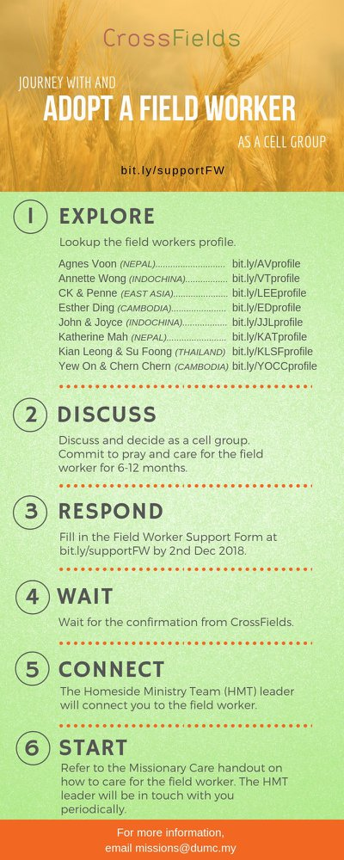

- CMS: Steps to Fill in the Salvation Form
- Select “More”
- “Form”
- Select “Form List” box
- Look for “Salvation Form”
- Fill in form of new salvation by “Change Respondent”
- Must have “E-mail” and “Mobile Phone”

UPCOMING

PREACHING SCHEDULE

30 Nov & 1 Dec | Advent – An Invitation to Christmas: Hope  (Luke 2:22-40 | Pr Gilbert Tan (DC)  Pr Tan Moy How (D@P)

Go to: http://www.dumc.my/resources/sermons/ for the latest info.

EVENT HIGHLIGHTS

  - Join The Celebrations in DUMC@Puchong at 10am Every Sunday
Bring your friends and family members living around the Puchong area. Look for DUMC@Puchong on Waze or Google Maps. (Please park at IOI Business Park Level B2)

  - CHURCH PRAYER ALTAR
Every Saturday | 7.00 -9.00am | Room 101 & 102
Let us come and seek the face of God. Prayer precedes everything.

  - TUESDAY ENCOUNTER NIGHT (3rd & 4th Tuesdays of every month)
26 Nov | 8.30pm-10.00pm | DUMC@Puchong
Come together and be refreshed by His presence.
Info? Contact forerunners@dumc.my

  - WANT TO JOIN THE DUMC FAMILY?
Here are the steps:
> Join a Cell Group (You can get help at our CG Kiosk)
> Attend Basic Christianity 101
> Attend DUMC 101
> Join an Encounter Weekend
> Baptism & Membership Interview
Sign up at the Info Counter or online at dumc.my/equip

  - IMPACT
2020·YOU·ME·theNATIONS
DUMC is turning 40 in 2020! It’s time to look outwards — beyond the four walls of our church. Info? Visit the IMPACT info booth or go to bit.ly/IMPACT2020DUMC

EQUIP COURSES 2019 & 2020

EVANGELISM 101 (Note: Membership Requirement)
Saturday | 30 Nov | 8.30am-1.00pm

PAUSE AND PONDER (Year-end Prayer and Reflection)
Saturday | 7 Dec | 8.30am-11.30am Register via: bit.ly/PPDec2019

SPIRITUAL FORMATION 301
Towards inner transformation in God
Saturdays | 15 Feb, 14 & 28 Mar, 4 & 18 Apr 2020 | 8.30am-11.00am
Includes a retreat 27 Feb – 1 Mar

ALPHA PREVIEW Food. Talk. Discussion.
Sunday | 23 Feb 2020 | 12.30pm-2.30pm

LIBRARY HOURS: CLOSED for renovation until further notice

Find out more about Equip courses at the Info Counter in Concourse 2, or online at http://dumc.my/equip

