CONTENTS

Worship
Word
Works
Upcoming:
Preaching Schedule
Event Highlights
Equip courses

WORSHIP (Praise and Prayer)

- Malaysia – Peace & Justice System
Pray:
- We will be committed ambassadors of reconciliation, reaching out boldly to the lost and the needy.
- For peace in our hearts, homes, communities, nation, and the world: a peace that the world cannot give, true peace that comes from the Prince of Peace.
- Over the justice system – police, judges, lawmakers – that all will work for the good of the nation, and establish a justice system that rests on God’s benchmark of truth and righteousness.

- International Day of Prayer for the Persecuted – Afghanistan
Ranked No.2 on the World Watch List, there are extremely high levels of persecution against Christians in the country. Most Afghan Christians live in hiding due to the fear of persecution.

Pray:
- For the safety of Afghan Christians who face high levels of oppression by radical Islamists.
- For grater religious freedom for Christians in Afghanistan.
- That God would govern over Christian minority communities and their actions.

WORD (60 minutes)

Advent: An Invitation to series:
Hope (Luke 2:22-40)
Pastor Gilbert Tan & Tan Moy How

BIG IDEA: Hope, in the Posture of Waiting

- Read the scripture passage.
- Do a THREE-MINUTE SUMMARY of the sermon highlighting the KEY POINTS. Do not preach the whole sermon, as majority of your members would have heard the sermon already. Allocate more time for sharing in the cell through the application questions below.
- Sermon Resource at: http://www.dumc.my/resources/sermons/

Reflection & Application Questions:

- Devotion to God: A relationship is developed over time. How are you developing your relationship with God so that you can hear clearly, like Simeon and Anna, when the Lord speaks?

- Trust and confidence in God: Share an instance where you were shaken by either a personal challenge or by a national crisis. How did you maintain your trust and confidence in God in such circumstances? What can we learn from Simeon and Anna?

- Gratitude to God: Jesus Christ is our glorious hope and we can give thanks to Him in all circumstances. Share an item of thanksgiving today and commit to 30 days of thanksgiving until year end (write down one item of thanksgiving per day).

Note to Word facilitator:
As you are preparing for this session, this is a great time to pray that the Holy Spirit will guide you to use the questions efficaciously. You can select, modify or entirely create your own questions, according to the needs of your CG, especially if you feel that there are too many questions than required for the allocated time.

Note to Cell Groups that have children during meeting:
We recognise several cell groups in DUMC may have 5 or more children joining them during Cell Group meetings. We would like to get them engaged as well during the session therefore we are suggesting for CGs to use Manna Pad and assign someone in rotation to facilitate them after worship. Here is the link to the Manna Pad materials http://dumc.my/resources/downloads/

WORKS (Ministry and Bearing Witness)

Cell leaders to ask these two important questions or share with one another during Works session in every CG meeting.

    - Who have I met, praying for and sharing Christ with?
    - What is the Holy Spirit saying about the community I am in?

- Christmas and Advent at DUMC (NEW)
Find out more information about the Advent and Christmas events at DUMC via http://dumc.my/christmas-2019/
Noteworthy items:
- Christmas and Advent themed celebrations in December
- E-invitation cards
- Christmas Initiatives:
  - Christmas Meal Packages: Options for home organized meals with pre-believers in hosting them. This is in support of Kelompok Kerja of Community Transformation Initiative.
  - After7 in December: It is Christmas themed for you to invite pre-believers this weekend!
  - Village Coffee: Seasonal items to provide opportunities of invitation for pre-believing friends and family members to the Dream Center for evangelism purposes
  - Notepad: Encourage writing of notes to one another to express genuine love. One notepad per individual available (hardcopies available for free until stocks last).

- Share Your Story (Your Story, His Glory)
- Whether your story is about how you came to know Christ, illness healed, an act of kindness in your times of need, or of how you served people or how people have served you, give glory to God. Share your story so that people will be encouraged and God's love is known.
- If there are any good testimonies, ask your members to write out their testimonies and submit to the church: http://dumc.my/connect/individual-care/share-your-story/

- Personal: Bible Reading and Journaling
- Subscribe to the app: YouVersion – OwnIt365 New Testament (NT)+ Plan.
- Request one of your members to share a journal entry. Pair up members to share with, and pray for one another.

- Scripture Memory
Every cell meeting, do get your cell members to recite the following together:

Galatians 5:25 (Theme verse for 2019)
Since we live by the Spirit, let us keep in step with the Spirit.

Galatians 2:20 (added from March 2019)
I have been crucified with Christ and I no longer live, but Christ lives in me. The life I now live in the body, I live by faith in the Son of God, who loved me and gave himself for me.

- CrossFields
Crossing into the harvest field with the message of the Cross.

Vietnam | 5 - 10 Dec
Nepal | 5-15 Dec
Sarawak Iban | 11-18 Dec

Website: dumc.my/missions
Mission trip dates: bit.ly/CF2019cal

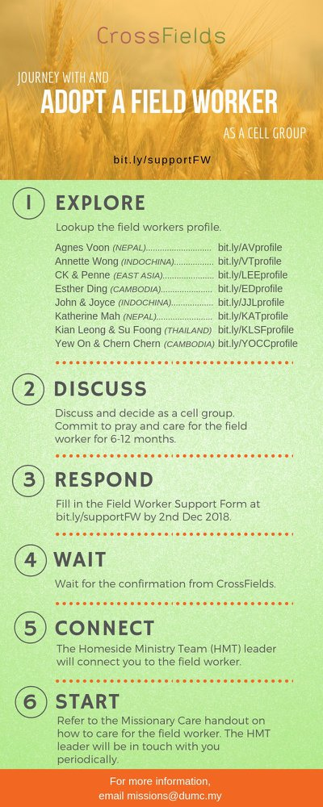

- CMS: Steps to Fill in the Salvation Form
- Select “More”
- “Form”
- Select “Form List” box
- Look for “Salvation Form”
- Fill in form of new salvation by “Change Respondent”
- Must have “E-mail” and “Mobile Phone”

UPCOMING

PREACHING SCHEDULE

30 Nov & 1 Dec | Advent – An Invitation to: Hope  (Luke 2:22-40) | Pr Gilbert Tan (DC)  Pr Tan Moy How (D@P)
7 & 8 Dec | Advent – An Invitation to: Love | Pr Mike Ngui (DC)  Pr Adrian Chong (D@P)
14 & 15 Dec | Advent – An Invitation to: Joy | Pr Dato Daniel Ho
21 & 22 Dec | Advent – An Invitation to: Peace | Pr Mike Ngui (DC)

Go to: http://www.dumc.my/resources/sermons/ for the latest info.

EVENT HIGHLIGHTS

  - Join The Celebrations in DUMC@Puchong at 10am Every Sunday
Bring your friends and family members living around the Puchong area. Look for DUMC@Puchong on Waze or Google Maps. (Please park at IOI Business Park Level B2)

  - CHURCH PRAYER ALTAR
Every Saturday | 7.00 -9.00am | Room 101 & 102
Let us come and seek the face of God. Prayer precedes everything.

  - TUESDAY ENCOUNTER NIGHT (3rd & 4th Tuesdays of every month)
Come together and be refreshed by His presence.
Info? Contact forerunners@dumc.my

  - WANT TO JOIN THE DUMC FAMILY?
Here are the steps:
> Join a Cell Group (You can get help at our CG Kiosk)
> Attend Basic Christianity 101
> Attend DUMC 101
> Join an Encounter Weekend
> Baptism & Membership Interview
Sign up at the Info Counter or online at dumc.my/equip

  - IMPACT
2020·YOU·ME·theNATIONS
DUMC is turning 40 in 2020! It’s time to look outwards — beyond the four walls of our church. Info? Visit the IMPACT info booth or go to bit.ly/IMPACT2020DUMC

EQUIP COURSES 2019 & 2020

PAUSE AND PONDER (Year-end Prayer and Reflection)
Saturday | 7 Dec | 8.30am-11.30am Register via: bit.ly/PPDec2019

SPIRITUAL FORMATION 301
Towards inner transformation in God
Saturdays | 15 Feb, 14 & 28 Mar, 4 & 18 Apr 2020 | 8.30am-11.00am
Includes a retreat 27 Feb – 1 Mar

ALPHA PREVIEW Food. Talk. Discussion.
Sunday | 23 Feb 2020 | 12.30pm-2.30pm

LIBRARY HOURS: CLOSED for renovation until further notice

Find out more about Equip courses at the Info Counter in Concourse 2, or online at http://dumc.my/equip

