CONTENTS

Worship
Word
Works
Upcoming:
Preaching Schedule
Event Highlights
Equip courses

WORSHIP (Praise and Prayer)

- Malaysia – Floods
At least 2 people have died and over 15,000 people are now displaced after flooding has worsened in the states of Kelantan and Terengganu in Malaysia over the last 24 hours. Flooding began in the state of Terengganu after heavy rain that began on 27 November. (Source: http://floodlist.com)
Pray:
· For affected victims, especially those in the interior that assistance will be accorded to them. For God’s comfort for those whose loved ones perished in the floods.
· The rain to let up and any potential flood averted; waters recede.
· The mobilisation of resources and assets by the state government in the relief/rebuilding works.
· The public including churches to step up in the relief and rescue work; for generous donors.

- Missions – Choo Yew On (YO) & Chern Chern (CC), Cambodia
Pray:
For the Spirit’s anointing and authority on YO who preaches at the Siem Reap Christian Fellowship (8 Dec).
· For YO’s Medical mission trip with Mt Carmel BP church to Andaut village (9-15 Dec).
· For CC’s teaching and training on Cleft Management at National Paediatric Hospital, Phnom Penh (13 Dec).
· Launching of CC’s book, ‘Lizard Tail’ at DUMC during the 14 & 15 December worship celebrations.

- Colombian – A nation ravaged by violence & corruption. A people demanding change.
In the 20th century, newly formed guerrilla and paramilitary groups began using violence to enact their political agendas. Many aligned themselves with profitable drug cartels, as Colombia is one of the world’s largest exporters of illegal drugs. Regrettably, poverty (37%), unemployment (over 10%), and drug trafficking-related issues, including fear, continue to overwhelm Colombia’s population.
Pray for:
· Spiritual and physical protection for believers who face the threat of violence for their commitments to Christ.
· A wise and courageous government that will take a hard stance against violence, drug cartels, and corruption.
· The spiritual battle for Colombia to be won in Jesus' Name through persistent and prevailing prayer.

WORD (60 minutes)

Advent: An Invitation to series:
LOVE (John: 3:14-17)
Pastor Mike Ngui

BIG IDEA: God shows us what it means to love, in giving Jesus

- Read the scripture passage.
- Do a THREE-MINUTE SUMMARY of the sermon highlighting the KEY POINTS. Do not preach the whole sermon, as majority of your members would have heard the sermon already. Allocate more time for sharing in the cell through the application questions below.
- Sermon Resource at: http://www.dumc.my/resources/sermons/

Reflection & Application Questions:

- Love beyond the warm and fuzzy: Jesus came into the world to die, to be the sacrifice for the sins of the world, your sin and my sin. How do you show the love of Christ to others by the actions of Christ?

- Bless others with Love: God loved us so much that He stepped out of Heaven and into our world, to share with us in our lives. Imagine Heaven in all its splendour, Jesus left all that and came into our dusty and hard human lives. How can you apply this to your life as a Christian?

- Experience God’s Love: We are not guest in God's house. We are His children and thus the host. What or where is God's house?

Note to Word facilitator:
As you are preparing for this session, this is a great time to pray that the Holy Spirit will guide you to use the questions efficaciously. You can select, modify or entirely create your own questions, according to the needs of your CG, especially if you feel that there are too many questions than required for the allocated time.

Note to Cell Groups that have children during meeting:
We recognise several cell groups in DUMC may have 5 or more children joining them during Cell Group meetings. We would like to get them engaged as well during the session therefore we are suggesting for CGs to use Manna Pad and assign someone in rotation to facilitate them after worship. Here is the link to the Manna Pad materials http://dumc.my/resources/downloads/

WORKS (Ministry and Bearing Witness)

Cell leaders to ask these two important questions or share with one another during Works session in every CG meeting.

    - Who have I met, praying for and sharing Christ with?
    - What is the Holy Spirit saying about the community I am in?

- Christmas and Advent at DUMC (NEW)
Find out more information about the Advent and Christmas events at DUMC via http://dumc.my/christmas-2019/
Noteworthy items:
- Christmas and Advent themed celebrations in December
- E-invitation cards
- Christmas Initiatives:
  - Christmas Meal Packages (only until 17 December): Options for home organized meals with pre-believers in hosting them. This is in support of Kelompok Kerja of Community Transformation Initiative.
  - Village Coffee: Seasonal items (only until 21 December) to provide opportunities of invitation for pre-believing friends and family members to the Dream Center for evangelism purposes. Only 2 Saturdays left.
  - Notepad: Encourage writing of notes to one another to express genuine love. One notepad per individual available (hardcopies available for free until stocks last).

- Share Your Story (Your Story, His Glory)
- Whether your story is about how you came to know Christ, illness healed, an act of kindness in your times of need, or of how you served people or how people have served you, give glory to God. Share your story so that people will be encouraged and God's love is known.
- If there are any good testimonies, ask your members to write out their testimonies and submit to the church: http://dumc.my/connect/individual-care/share-your-story/

- Personal: Bible Reading and Journaling
- Subscribe to the app: YouVersion – OwnIt365 New Testament (NT)+ Plan.
- Request one of your members to share a journal entry. Pair up members to share with, and pray for one another.

- Scripture Memory
Every cell meeting, do get your cell members to recite the following together:

Galatians 5:25 (Theme verse for 2019)
Since we live by the Spirit, let us keep in step with the Spirit.

Galatians 2:20 (added from March 2019)
I have been crucified with Christ and I no longer live, but Christ lives in me. The life I now live in the body, I live by faith in the Son of God, who loved me and gave himself for me.

- CrossFields
Crossing into the harvest field with the message of the Cross.

Vietnam | 5 - 10 Dec
Nepal | 5-15 Dec
Sarawak Iban | 11-18 Dec

Website: dumc.my/missions
Mission trip dates: bit.ly/CF2019cal

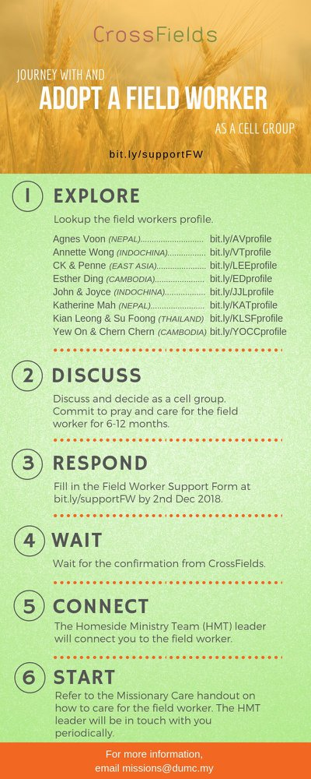

- CMS: Steps to Fill in the Salvation Form
- Select “More”
- “Form”
- Select “Form List” box
- Look for “Salvation Form”
- Fill in form of new salvation by “Change Respondent”
- Must have “E-mail” and “Mobile Phone”

UPCOMING

PREACHING SCHEDULE

14 & 15 Dec | Advent – An Invitation to: Joy | Pr Dato Daniel Ho
21 & 22 Dec | Advent – An Invitation to: Peace | Pr Mike Ngui (DC)

Go to: http://www.dumc.my/resources/sermons/ for the latest info.

EVENT HIGHLIGHTS

  - Join The Celebrations in DUMC@Puchong at 10am Every Sunday
Bring your friends and family members living around the Puchong area. Look for DUMC@Puchong on Waze or Google Maps. (Please park at IOI Business Park Level B2)

  - CHURCH PRAYER ALTAR
Every Saturday | 7.00 -9.00am | Room 101 & 102
Let us come and seek the face of God. Prayer precedes everything.

  - TUESDAY ENCOUNTER NIGHT (3rd & 4th Tuesdays of every month)
Come together and be refreshed by His presence.
Info? Contact forerunners@dumc.my

  - WANT TO JOIN THE DUMC FAMILY?
Here are the steps:
> Join a Cell Group (You can get help at our CG Kiosk)
> Attend Basic Christianity 101
> Attend DUMC 101
> Join an Encounter Weekend
> Baptism & Membership Interview
Sign up at the Info Counter or online at dumc.my/equip

  - IMPACT
2020·YOU·ME·theNATIONS
DUMC is turning 40 in 2020! It’s time to look outwards — beyond the four walls of our church. Info? Visit the IMPACT info booth or go to bit.ly/IMPACT2020DUMC

EQUIP COURSES 2019 & 2020

LECTIO DIVINA WORKSHOP
Saturday | 4 Jan | 9.30am-10.45am
Saturday | 5 Jan | 8.00am-9.15am
Register via bit.ly/LDWJan2020

SPIRITUAL FORMATION 301
Towards inner transformation in God
Saturdays | 15 Feb, 14 & 28 Mar, 4 & 18 Apr 2020 | 8.30am-11.00am
Includes a retreat 27 Feb – 1 Mar

ALPHA PREVIEW Food. Talk. Discussion.
Sunday | 23 Feb 2020 | 12.30pm-2.30pm

LIBRARY HOURS: CLOSED for renovation until further notice

Find out more about Equip courses at the Info Counter in Concourse 2, or online at http://dumc.my/equip

