CONTENTS

Worship
Word
Works
Upcoming:
Preaching Schedule
Event Highlights
Equip courses

WORSHIP (Praise and Prayer)

- Malaysia – Government,Corruption,Church
Pray:
- For stability and unity in the government:that they will be of one mind and heart, and be protected from internal politicking and power jostling.
- For the prompt conclusion to all the national corruption cases involving the loss of national wealth and several cases involving politicians.
- That the Holy Spirit will be poured out upon our nation to cleanse and purify her from all sin and evil. Breakdown all wicked strongholds and drive out all demonic powers so that the church will be purified and the people of the nation be blessed.
- Missions – Choo Yew On (YO) & Chern Chern (CC), Cambodia
Pray for:
- Good family time in Cambodia-Niklas and Joshua arrives on 16&20 December respectively

- Middle East & North Africa: SAT 7 teaches kids about their rights .
SAT 7,a satellite TV ministry to the Middle East and North Africa is teaching children their rights. Puzzle is a gameshow where children from different religious backgrounds are taught their rights in a fun way by professionals. Messages about rights and working together have resonated not only with kids ,but also with parents.
Pray that:
- Love and acceptance will be communicated and experienced by the children through this programme.
- The Holy Spirit will grow the seeds planted-hope ,reconciliation and belonging-and thus enable the children and their families to know and experience God’s truth.
- Sat -&7 Academy will be able to continue to advocate for children while making the Gospel accessible in new places .

- DUMC Christmas Outreach
Pray for:
- Our availability to be at God’s disposal to be used as HIS channel of blessing to the unchurched .
- Opportunities to witness to our loved ones and oikoses(families)

WORD (60 minutes)

Advent: An Invitation to series:
JOY (Luke 2:8-11)
Founding Senior Pastor:Dato’Dr Daniel Ho

- Read the scripture passage.
- Do a THREE-MINUTE SUMMARY of the sermon highlighting the KEY POINTS. Do not preach the whole sermon, as majority of your members would have heard the sermon already. Allocate more time for sharing in the cell through the application questions below.
- Sermon Resource at: http://www.dumc.my/resources/sermons/

Reflection & Application Questions:

- We are often caught up with loads of bad news nowdays but there is also good news and we thank to God for that, please share what is the best news you have got recently and how did you give thanks to God for this?

- In this season of advent we have the greatest news to share that is about the birth of our saviour . What steps have you taken to fully appreciate this great news and how is this shown in your life as a Christian?

- Is Joy and Happiness the same ? Yes /No ?

Note to Word facilitator:
As you are preparing for this session, this is a great time to pray that the Holy Spirit will guide you to use the questions efficaciously. You can select, modify or entirely create your own questions, according to the needs of your CG, especially if you feel that there are too many questions than required for the allocated time.

Note to Cell Groups that have children during meeting:
We recognize several cell groups in DUMC may have 5 or more children joining them during Cell Group meetings. We would like to get them engaged as well during the session therefore we are suggesting for CGs to use Manna Pad and assign someone in rotation to facilitate them after worship. Here is the link to the Manna Pad materials http://dumc.my/resources/downloads/

WORKS (Ministry and Bearing Witness)

Cell leaders to ask these two important questions or share with one another during Works session in every CG meeting.

    - Who have I met, praying for and sharing Christ with?
    - What is the Holy Spirit saying about the community I am in?

- Christmas and Advent at DUMC (NEW)
Find out more information about the Advent and Christmas events at DUMC via http://dumc.my/christmas-2019/
Noteworthy items:
- Christmas and Advent themed celebrations in December
- E-invitation cards
- Christmas Initiatives:
  - Christmas Meal Packages: The initiative has ended, therefore the form is now closed and we are no longer receiving orders. We would like to thank you for your support as the proceeds go towards building up the people of the Community Transformation Initiative. To learn more and see how you can support the projects under CTI, head over to cti.org.my
  - Village Coffee: Use our Christmas Tea Sets initiative as a platform to have life-giving conversations and catch-ups with your loved ones.
Only one Saturday left! Limited sets available for both walk-ins and pre-orders!
Date: Dec 21st 2019, Saturday
Time: 2.00pm - 4.30pm
To pre-order, please fill up this form: bit.lt/christmas2019teaset

- Share Your Story (Your Story, His Glory)
- Whether your story is about how you came to know Christ, illness healed, an act of kindness in your times of need, or of how you served people or how people have served you, give glory to God. Share your story so that people will be encouraged and God's love is known.
- If there are any good testimonies, ask your members to write out their testimonies and submit to the church: http://dumc.my/connect/individual-care/share-your-story/

- Personal: Bible Reading and Journaling
- Subscribe to the app: YouVersion – OwnIt365 New Testament (NT)+ Plan.
- Request one of your members to share a journal entry. Pair up members to share with, and pray for one another.

- Scripture Memory
Every cell meeting, do get your cell members to recite the following together:

Galatians 5:25 (Theme verse for 2019)
Since we live by the Spirit, let us keep in step with the Spirit.

Galatians 2:20 (added from March 2019)
I have been crucified with Christ and I no longer live, but Christ lives in me. The life I now live in the body, I live by faith in the Son of God, who loved me and gave himself for me.

- CrossFields
Crossing into the harvest field with the message of the Cross.

Sarawak Iban | 11-18 Dec

Website: dumc.my/missions
Mission trip dates: bit.ly/CF2019cal

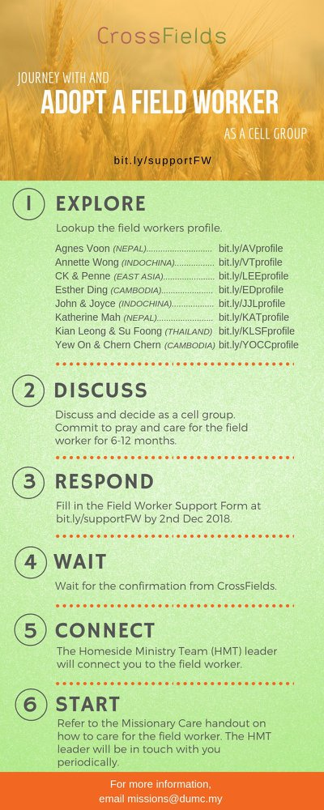

- CMS: Steps to Fill in the Salvation Form
- Select “More”
- “Form”
- Select “Form List” box
- Look for “Salvation Form”
- Fill in form of new salvation by “Change Respondent”
- Must have “E-mail” and “Mobile Phone”

UPCOMING

PREACHING SCHEDULE

21 & 22 Dec | Advent – An Invitation to: Peace | Pr Mike Ngui (DC)

Go to: http://www.dumc.my/resources/sermons/ for the latest info.

EVENT HIGHLIGHTS

  - Join The Celebrations in DUMC@Puchong at 10am Every Sunday
Bring your friends and family members living around the Puchong area. Look for DUMC@Puchong on Waze or Google Maps. (Please park at IOI Business Park Level B2)

  - CHURCH PRAYER ALTAR
Every Saturday | 7.00 -9.00am | Room 101 & 102
Let us come and seek the face of God. Prayer precedes everything.

  - TUESDAY ENCOUNTER NIGHT (3rd & 4th Tuesdays of every month)
Come together and be refreshed by His presence.
Info? Contact forerunners@dumc.my

  - WANT TO JOIN THE DUMC FAMILY?
Here are the steps:
> Join a Cell Group (You can get help at our CG Kiosk)
> Attend Basic Christianity 101
> Attend DUMC 101
> Join an Encounter Weekend
> Baptism & Membership Interview
Sign up at the Info Counter or online at dumc.my/equip

  - IMPACT
2020·YOU·ME·theNATIONS
DUMC is turning 40 in 2020! It’s time to look outwards — beyond the four walls of our church. Info? Visit the IMPACT info booth or go to bit.ly/IMPACT2020DUMC

EQUIP COURSES 2019 & 2020

LECTIO DIVINA WORKSHOP
Saturday | 4 Jan | 9.30am-10.45am
Saturday | 5 Jan | 8.00am-9.15am
Register via bit.ly/LDWJan2020

SPIRITUAL FORMATION 301
Towards inner transformation in God
Saturdays | 15 Feb, 14 & 28 Mar, 4 & 18 Apr 2020 | 8.30am-11.00am
Includes a retreat 27 Feb – 1 Mar

ALPHA PREVIEW Food. Talk. Discussion.
Sunday | 23 Feb 2020 | 12.30pm-2.30pm

LIBRARY HOURS: CLOSED for renovation until further notice

Find out more about Equip courses at the Info Counter in Concourse 2, or online at http://dumc.my/equip

