CONTENTS

Worship
Word
Works
Upcoming:
Preaching Schedule
Event Highlights
Equip courses

WORSHIP (Praise and Prayer)

- Persecuted Christians - Uniting in Prayer
During this Christmas season, let us remember our brothers and sisters globally who face persecution.
Pray:
- That the Holy Spirit will enable them to forgive and love their persecutors (Matt 5:44); that their Christ-like reactions will have an impact on their persecutors.
- For the Lord to work in the hearts of those who currently persecute our sisters and brothers to bring them to a saving knowledge of Himself, as He did with Saul of Tarsus (Acts 9).
- For God’s protection of His people who gather to worship particularly on Christmas Day.

- Malaysia
Pray for:
- Prayer leaders and intercessors to come from every state, ready and prepared to be mobilised for 24-7 prayer.
- Them to light up the nation in prayer, bringing God’s righteousness as the foundation of the governance of this nation.
- Them to build up prayer walls to protect the nation from the concerted attacks of the evil one

- IMPACT2020
Pray for:
Cell Groups
- God will unite their hearts and show them the community and location which He wants them to reach in love with the Good News.
- Pray that they will embrace His calling and plan for them with glad and sincere hearts.

Impact Fields
- God will prepare the hosting church/organisations to work in collaboration with us in God's missional work.

WORD (60 minutes)

Advent: An Invitation to series:
PEACE (Luke 2:8-15)
Pastor Mike Ngui

BIG IDEA:
Christmas – the coming of Christ – is for peace on earth

- Read the scripture passage.
- Do a THREE-MINUTE SUMMARY of the sermon highlighting the KEY POINTS. Do not preach the whole sermon, as majority of your members would have heard the sermon already. Allocate more time for sharing in the cell through the application questions below.
- Sermon Resource at: http://www.dumc.my/resources/sermons/

Reflection & Application Questions:

- For Ourselves - peace is more than absence of conflict. Do you have the Peace of God in your heart or hiding from it? What would you like to personally surrender to God this day to experience the peace (Shalom) for yourself?

- For Others - have you achieve wholeness in your life? Shalom to others is more than laying down our ‘arms’ (defences) but of restoring relationship with one another; restoring what is broken down and building it up with the love of Christ. Are there any relationship you need to amend or ‘make peace’ in order to reflect Christlikeness in our life?

- For The Nation - the Aaronic Blessing proclaims peace and restoration. The coming of Christ aims to bring peace to the nation. Do we join our society to complain and quarrel rather than promoting peace? How do we as CG/Church proclaim that gospel of peace to the society?

- For God’s Kingdom - as we celebrate this season of Christmas together with a new beginning of 2020, each of us or as a group needs to demonstrate shalom and spread the good news through our testimonies of God’s peace. Share an instance when you care, help or prayed for someone who needed Christ’s peace and how they responded to it. If you have no encounters as yet, what opportunities that you can intentionally create this week to bring blessings to other?

Note to Word facilitator:
As you are preparing for this session, this is a great time to pray that the Holy Spirit will guide you to use the questions efficaciously. You can select, modify or entirely create your own questions, according to the needs of your CG, especially if you feel that there are too many questions than required for the allocated time.

Note to Cell Groups that have children during meeting:
We recognize several cell groups in DUMC may have 5 or more children joining them during Cell Group meetings. We would like to get them engaged as well during the session therefore we are suggesting for CGs to use Manna Pad and assign someone in rotation to facilitate them after worship. Here is the link to the Manna Pad materials http://dumc.my/resources/downloads/

WORKS (Ministry and Bearing Witness)

Cell leaders to ask these two important questions or share with one another during Works session in every CG meeting.

    - Who have I met, praying for and sharing Christ with?
    - What is the Holy Spirit saying about the community I am in?

- Christmas and Advent at DUMC (NEW)
Find out more information about the Advent and Christmas events at DUMC via http://dumc.my/christmas-2019/
Noteworthy items:
- Christmas and Advent themed celebrations in December
- E-invitation cards

- Share Your Story (Your Story, His Glory)
- Whether your story is about how you came to know Christ, illness healed, an act of kindness in your times of need, or of how you served people or how people have served you, give glory to God. Share your story so that people will be encouraged and God's love is known.
- If there are any good testimonies, ask your members to write out their testimonies and submit to the church: http://dumc.my/connect/individual-care/share-your-story/

- Personal: Bible Reading and Journaling
- Subscribe to the app: YouVersion – OwnIt365 New Testament (NT)+ Plan.
- Request one of your members to share a journal entry. Pair up members to share with, and pray for one another.

- Scripture Memory
Every cell meeting, do get your cell members to recite the following together:

Galatians 5:25 (Theme verse for 2019)
Since we live by the Spirit, let us keep in step with the Spirit.

Galatians 2:20 (added from March 2019)
I have been crucified with Christ and I no longer live, but Christ lives in me. The life I now live in the body, I live by faith in the Son of God, who loved me and gave himself for me.

- CrossFields
Crossing into the harvest field with the message of the Cross.
Website: dumc.my/missions
Mission trip dates: bit.ly/CF2019cal

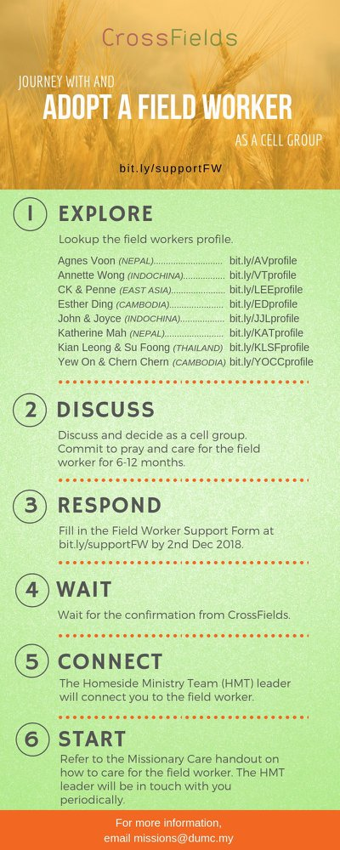

- CMS: Steps to Fill in the Salvation Form
- Select “More”
- “Form”
- Select “Form List” box
- Look for “Salvation Form”
- Fill in form of new salvation by “Change Respondent”
- Must have “E-mail” and “Mobile Phone”

UPCOMING

PREACHING SCHEDULE

28 & 29 Dec | STEP FORWARD – A Different Spirit | Sr Pr Chris Kam

Go to: http://www.dumc.my/resources/sermons/ for the latest info.

EVENT HIGHLIGHTS

  - Join The Celebrations in DUMC@Puchong at 10am Every Sunday
Bring your friends and family members living around the Puchong area. Look for DUMC@Puchong on Waze or Google Maps. (Please park at IOI Business Park Level B2)

  - WATCHNIGHT CELEBRATION
31 Dec | 10.00pm | Auditorium, DC
Let’s come together to celebrate God’s goodness and faithfulness for the year. See you there!

  - COMBINED CELEBRATIONS
4 Jan | 11.45pm | Auditorium, DC
5 Jan | 10.00am | Auditorium, DC
Let's celebrate DUMC’s 40th anniversary together! There will be NO 5.00pm Saturday celebration (English). See you there!

  - 5-DAY FAST & PRAYER 2020
13-17 Jan | 8.30pm | Auditorium, DC
Repentance, Restoration, Renewal Info? Email forerunners@dumc.my

  - CHURCH PRAYER ALTAR
Every Saturday | 7.00 -9.00am | Room 101 & 102
Let us come and seek the face of God. Prayer precedes everything.

  - TUESDAY ENCOUNTER NIGHT (3rd & 4th Tuesdays of every month)
Come together and be refreshed by His presence.
Info? Contact forerunners@dumc.my

  - WANT TO JOIN THE DUMC FAMILY?
Here are the steps:
> Join a Cell Group (You can get help at our CG Kiosk)
> Attend Basic Christianity 101
> Attend DUMC 101
> Join an Encounter Weekend
> Baptism & Membership Interview
Sign up at the Info Counter or online at dumc.my/equip

  - IMPACT2020 ·YOU·ME·theNATIONS
DUMC is turning 40 in 2020! It’s time to look outwards — beyond the four walls of our church. Info? Visit the IMPACT info booth or go to bit.ly/IMPACT2020DUMC

EQUIP COURSES 2019 & 2020

LECTIO DIVINA WORKSHOP
Saturday | 4 Jan | 9.30am-10.45am
Saturday | 5 Jan | 8.00am-9.15am
Register via bit.ly/LDWJan2020

SPIRITUAL FORMATION 301
Towards inner transformation in God
Saturdays | 15 Feb, 14 & 28 Mar, 4 & 18 Apr 2020 | 8.30am-11.00am
Includes a retreat 27 Feb – 1 Mar

ALPHA PREVIEW Food. Talk. Discussion.
Sunday | 23 Feb 2020 | 12.30pm-2.30pm (DUMC@Puchong)
Thursday | 27 Feb | 7.00pm-9.00pm (Dream Centre)

LIBRARY HOURS: CLOSED for renovation until further notice

Find out more about Equip courses at the Info Counter in Concourse 2, or online at http://dumc.my/equip

