CONTENTS

Worship (3rd week of the month, kindly organise the Lord’s Supper)
Word
Works
Upcoming:
Preaching Schedule
Event Highlights
Equip courses

WORSHIP (Praise and Prayer)

- Malaysia – Leaders
Since GE14 on 9 May 2018, there have been 9 by-elections, out of which, 6 resulted from the untimely demise of the elected representatives. The Bible warns and reminds us in Ephesians 6:12, “For we do not wrestle against flesh and blood, but against the rulers, against the authorities, against the cosmic powers over this present darkness, against the spiritual forces of evil in the heavenly places.”

Let us pray specifically for the State Assemblyman (ADUN) and Member of Parliament (MP) in our respective state and parliamentary constituencies:

Pray for:
- Health and well-being and that they will be protected from the attacks of demonic powers.
- The will and desire to focus on serving the people and nation.

- International Day of Prayer for the Persecuted – Saudi Arabia
This November, millions of Christians worldwide will unite for one cause: to join the global Body of Christ for the 2019 International Day of Prayer for the Persecuted (IDOP). The number one thing persecuted Christians ask for is prayer.

Saudi Arabia is a country located in Southwest Asia. It is home to Islam’s holiest shrines in Medina and Mecca. According to Open Doors – World Watch List, Saudi Arabia has a population of 33.5 million people of which 1.4 million are Christians. Christians in Saudi Arabia endure a significant level of Islamist oppression.

Pray for:
- God’s protection and strength over the converted as they face a high risk of persecution.
- Isolated secret believers. For God’s guidance, protection and comfort over them.
- Christians, so they will soon be able to practice their faith without fear of persecution.

WORD (60 minutes)

The Mission Heart of God series:
For the People Here (Matthew 9:35-38; Acts 1:8)
Pastor Datuk Kee Sue Sing

BIG IDEA: Our mission field is over there, right here, and everywhere. Get busy!

- Read the scripture passage.
- Do a THREE-MINUTE SUMMARY of the sermon highlighting the KEY POINTS. Do not preach the whole sermon, as majority of your members would have heard the sermon already. Allocate more time for sharing in the cell through the application questions below.
- Sermon Resource at: http://www.dumc.my/resources/sermons/

Reflection & Application Questions:
“Jerusalem”, as per the sermon, is defined as the sum total of the pre-believers in your social network. It includes: friends, relatives, neighbours, fellow workers, foreigners in our midst, university/college/school maters, etc.

- What is your “Jerusalem”? How are you currently reaching the people there? IF you were to give yourself a letter grade A through F, what would your grade be?

- What are the challenges to reaching your “Jerusalem”? What would you do next to be a better witness there? (Consider the Christmas Outreach plan that has already been sent through to the CG Leaders this month)

- Who are the people you don’t want God to send you to? Who do you think God is using to reach them today? How can you and your Cell be a part of reaching them?

Note to Word facilitator:
As you are preparing for this session, this is a great time to pray that the Holy Spirit will guide you to use the questions efficaciously. You can select, modify or entirely create your own questions, according to the needs of your CG, especially if you feel that there are too many questions than required for the allocated time.

Note to Cell Groups that have children during meeting:
We recognise several cell groups in DUMC may have 5 or more children joining them during Cell Group meetings. We would like to get them engaged as well during the session therefore we are suggesting for CGs to use Manna Pad and assign someone in rotation to facilitate them after worship. Here is the link to the Manna Pad materials http://dumc.my/resources/downloads/

WORKS (Ministry and Bearing Witness)

Cell leaders to ask these two important questions or share with one another during Works session in every CG meeting.

    - Who have I met, praying for and sharing Christ with?
    - What is the Holy Spirit saying about the community I am in?

- Share Your Story (Your Story, His Glory)
- Whether your story is about how you came to know Christ, illness healed, an act of kindness in your times of need, or of how you served people or how people have served you, give glory to God. Share your story so that people will be encouraged and God's love is known.
- If there are any good testimonies, ask your members to write out their testimonies and submit to the church: http://dumc.my/connect/individual-care/share-your-story/

- Personal: Bible Reading and Journaling
- Subscribe to the app: YouVersion – OwnIt365 New Testament (NT)+ Plan.
- Request one of your members to share a journal entry. Pair up members to share with, and pray for one another.

- Scripture Memory
Every cell meeting, do get your cell members to recite the following together:

Galatians 5:25 (Theme verse for 2019)
Since we live by the Spirit, let us keep in step with the Spirit.

Galatians 2:20 (added from March 2019)
I have been crucified with Christ and I no longer live, but Christ lives in me. The life I now live in the body, I live by faith in the Son of God, who loved me and gave himself for me.

- CrossFields
Crossing into the harvest field with the message of the Cross.

Cambodia | 14-22 Nov
Sarawak Penan | 30 Nov - 6 Dec
Vietnam | 5 - 10 Dec
Nepal | 5-15 Dec
Sarawak Iban | 11-18 Dec

Website: dumc.my/missions
Mission trip dates: bit.ly/CF2019cal

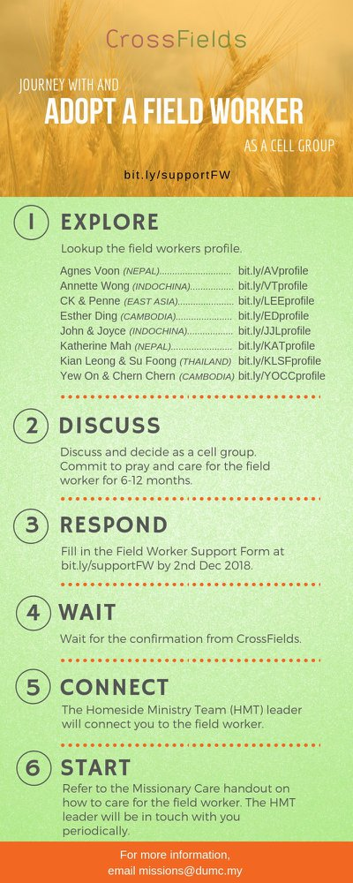

- CMS: Steps to Fill in the Salvation Form
- Select “More”
- “Form”
- Select “Form List” box
- Look for “Salvation Form”
- Fill in form of new salvation by “Change Respondent”
- Must have “E-mail” and “Mobile Phone”

UPCOMING

PREACHING SCHEDULE

23 & 24 Nov | Mission Heart of God 4: Stand on the Hill | Dato’ Dennis Ignatius

Go to: http://www.dumc.my/resources/sermons/ for the latest info.

EVENT HIGHLIGHTS

  - Join The Celebrations in DUMC@Puchong at 10am Every Sunday
Bring your friends and family members living around the Puchong area. Look for DUMC@Puchong on Waze or Google Maps. (Please park at IOI Business Park Level B2)

  - W2W ENCOUNTER
22-24 Nov | Grand Kampar Hotel A weekend getaway specially for women.
Register at bit.ly/ew-nov19 or Info Counter!

  - CHURCH PRAYER ALTAR
Every Saturday | 7.00 -9.00am | Room 101 & 102
Let us come and seek the face of God. Prayer precedes everything.

  - TUESDAY ENCOUNTER NIGHT (3rd & 4th Tuesdays of every month)
19 Nov | 8.30pm-10.00pm | Hall 3, DC
26 Nov | 8.30pm-10.00pm | DUMC@Puchong
Come together and be refreshed by His presence.
Info? Contact forerunners@dumc.my

  - WANT TO JOIN THE DUMC FAMILY?
Here are the steps:
> Join a Cell Group (You can get help at our CG Kiosk)
> Attend Basic Christianity 101
> Attend DUMC 101
> Join an Encounter Weekend
> Baptism & Membership Interview
Sign up at the Info Counter or online at dumc.my/equip

  - IMPACT
2020·YOU·ME·theNATIONS
DUMC is turning 40 in 2020! It’s time to look outwards — beyond the four walls of our church. Info? Visit the IMPACT info booth or go to bit.ly/IMPACT2020DUMC

EQUIP COURSES 2019 & 2020

EVANGELISM 101 (Note: Membership Requirement)
Saturday | 30 Nov | 8.30am-1.00pm

PAUSE AND PONDER (Year-end Prayer and Reflection)
Saturday | 7 Dec | 8.30am-11.30am Register via: bit.ly/PPDec2019

ALPHA PREVIEW Food. Talk. Discussion.
Sunday | 23 Feb 2020 | 12.30pm-2.30pm

LIBRARY HOURS: CLOSED for renovation until further notice

Find out more about Equip courses at the Info Counter in Concourse 2, or online at http://dumc.my/equip

