BLESSED NEW YEAR 2020!

CONTENTS

Worship
Word
Works
Upcoming:
Preaching Schedule
Event Highlights
Equip courses

WORSHIP (Praise and Prayer)

- GOD REIGNS
God reigns and is moving today in every corner of the globe! Yet the evil in our world and its prominence in news reports can sometimes make us lose sight of this. When we forget His sovereignty, we can easily slip into despair and hopelessness. As we look back over 2019 we recognize and rejoice that He reigns “far above all rule and authority, power and dominion, and every title…” and that “all things are under His feet” (Ephesians 1:21, 22). “The LORD has established His throne in heaven, and His kingdom rules over all” (Psalms 103:19). Nothing has or ever will usurp His authority and power. He reigns and He rules over Iran and China. North Korea and Syria. A deluge in Mozambique and a water shortage in India. He rules over kings and princes, presidents and prime ministers. He rules over cyclones and volcanoes, floods and fires. Protests, perpetrators, persecution, and refugees. He rules over corporations, celebrities, and sports. He rules over galaxies, stars, and planets “and calls them each by name” (Psalms 147:5).

Let us recall the events of 2019 through the lens of His love for the world and His sovereignty and reign over it. “You rule over all the kingdoms of the nations. Power and might are in your hand…” (2 Chronicles 20:6). (Source: Prayercast)

- Malaysia
Pray:
- For the government to have the will to bring about transformations in Malaysia.
- That the National Transformation Agenda will be given a high priority, all ministers and all law-makers will put forward fresh and bold policies that will bring about a process of Transformation to Malaysia.
- That they will lead this nation with selflessness and generosity.
- For political stability which will bring about economic prosperity and stability in Malaysia.
- That the enemy cannot take advantage of the struggle to create havoc and confusion in our country

WORD (60 Minutes)

A Different Spirit
(Numbers 13:26-30, 14:20-24)
Senior Pastor Chris Kam

BIG IDEA:
Out of your comfort zone. Embrace a different spirit.

- Read the scripture passage.
- Do a THREE-MINUTE SUMMARY of the sermon highlighting the KEY POINTS. Do not preach the whole sermon, as majority of your members would have heard the sermon already. Allocate more time for sharing in the cell through the application questions below.
- Sermon Resource at: http://www.dumc.my/resources/sermons/

Reflection & Application Questions:

- What does it mean for us to have a different spirit? 2019 Reflection: Do we intentionally build others up or often tearing others down through our complaints and grumbling? Are you a charger or discharger?

- 10 of the explorer’s (spies) said ‘but’ and were afraid to go in the promise land despite what God has said. What are your ‘but/s’ in stepping forward for God? Do you know what God’s will is for you?

- To seek God’s will we need to be consistent with our personal devotion to God and hear Him clearly. Would you want to start or continue to be regular in drawing to God in His word through devotion? Plan to do Lectio Divina and be accountable together as a CG.

- We need to be ‘fresh’ with our experience with God and renew our passion with God in the coming year. Make a decision to be serious with God and pray together as a CG for a year of IMPACT for the Lord. Think, write down and share 3 to 5 New Year’s resolution obedience in 2020.

Note to Word facilitator:
As you are preparing for this session, this is a great time to pray that the Holy Spirit will guide you to use the questions efficaciously. You can select, modify or entirely create your own questions, according to the needs of your CG, especially if you feel that there are too many questions than required for the allocated time.

Note to Cell Groups that have children during meeting:
We recognize several cell groups in DUMC may have 5 or more children joining them during Cell Group meetings. We would like to get them engaged as well during the session therefore we are suggesting for CGs to use Manna Pad and assign someone in rotation to facilitate them after worship. Here is the link to the Manna Pad materials http://dumc.my/resources/downloads/

WORKS (Ministry and Bearing Witness)

Cell leaders to ask these two important questions or share with one another during Works session in every CG meeting.

    - Who have I met, praying for and sharing Christ with?
    - What is the Holy Spirit saying about the community I am in?

- Share Your Story (Your Story, His Glory)
- Whether your story is about how you came to know Christ, illness healed, an act of kindness in your times of need, or of how you served people or how people have served you, give glory to God. Share your story so that people will be encouraged and God's love is known.
- If there are any good testimonies, ask your members to write out their testimonies and submit to the church: http://dumc.my/connect/individual-care/share-your-story/

- Personal: Bible Reading and Journaling
- Subscribe to the app: YouVersion – OwnIt365 New Testament (NT)+ Plan.
- Request one of your members to share a journal entry. Pair up members to share with, and pray for one another.

- Scripture Memory
Every cell meeting, do get your cell members to recite the following together:

Galatians 5:25 (Theme verse for 2019)
Since we live by the Spirit, let us keep in step with the Spirit.

Galatians 2:20 (added from March 2019)
I have been crucified with Christ and I no longer live, but Christ lives in me. The life I now live in the body, I live by faith in the Son of God, who loved me and gave himself for me.

- CrossFields
Crossing into the harvest field with the message of the Cross.
Website: dumc.my/missions
Mission trip dates: bit.ly/CF2019cal

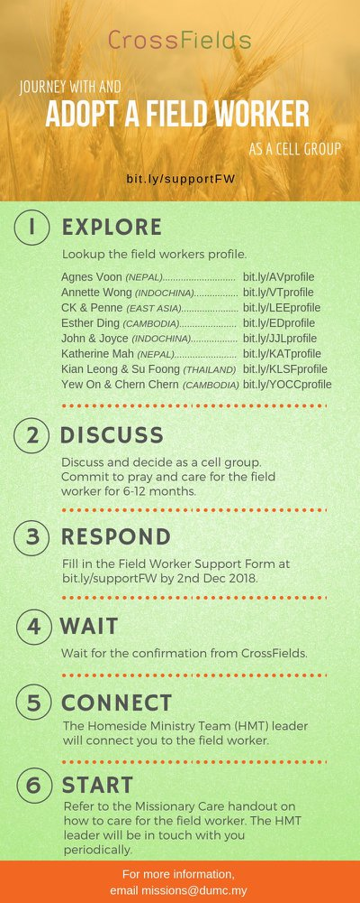

- CMS: Steps to Fill in the Salvation Form
- Select “More”
- “Form”
- Select “Form List” box
- Look for “Salvation Form”
- Fill in form of new salvation by “Change Respondent”
- Must have “E-mail” and “Mobile Phone”

UPCOMING

PREACHING SCHEDULE

31 Dec 2019 | WATCHNIGHT – Covenant Renewal Service | Sr Pr Chris Kam
4 & 5 Jan 2020 | FORWARD 2020 – Continuing the Race | FSP Dato Dr Daniel Ho
11 & 12 Jan 2020 | IMPACT 2020 – Philip and the Eunuch | Sr Pr Chris Kam

Go to: http://www.dumc.my/resources/sermons/ for the latest info.

EVENT HIGHLIGHTS

  - Join The Celebrations in DUMC@Puchong at 10am Every Sunday
Bring your friends and family members living around the Puchong area. Look for DUMC@Puchong on Waze or Google Maps. (Please park at IOI Business Park Level B2)

  - WATCHNIGHT CELEBRATION
31 Dec | 10.00pm | Auditorium, DC
Let’s come together to celebrate God’s goodness and faithfulness for the year. See you there!

  - COMBINED CELEBRATIONS
4 Jan | 11.45pm | Auditorium, DC
5 Jan | 10.00am | Auditorium, DC
Let's celebrate DUMC’s 40th anniversary together! There will be NO 5.00pm Saturday celebration (English). See you there!

  - 5-DAY FAST & PRAYER 2020
13-17 Jan | 8.30pm | Auditorium, DC
Repentance, Restoration, Renewal Info? Email forerunners@dumc.my

  - CHURCH PRAYER ALTAR
Every Saturday | 7.00 -9.00am | Room 101 & 102
Let us come and seek the face of God. Prayer precedes everything.

  - TUESDAY ENCOUNTER NIGHT (3rd & 4th Tuesdays of every month)
Come together and be refreshed by His presence.
Info? Contact forerunners@dumc.my

  - WANT TO JOIN THE DUMC FAMILY?
Here are the steps:
> Join a Cell Group (You can get help at our CG Kiosk)
> Attend Basic Christianity 101
> Attend DUMC 101
> Join an Encounter Weekend
> Baptism & Membership Interview
Sign up at the Info Counter or online at dumc.my/equip

  - IMPACT2020 ·YOU·ME·theNATIONS
DUMC is turning 40 in 2020! It’s time to look outwards — beyond the four walls of our church. Info? Visit the IMPACT info booth or go to bit.ly/IMPACT2020DUMC

EQUIP COURSES 2019 & 2020

LECTIO DIVINA WORKSHOP
Saturday | 4 Jan | 9.30am-10.45am
Saturday | 5 Jan | 8.00am-9.15am
Register via bit.ly/LDWJan2020

SPIRITUAL FORMATION 301
Towards inner transformation in God
Saturdays | 15 Feb, 14 & 28 Mar, 4 & 18 Apr 2020 | 8.30am-11.00am
Includes a retreat 27 Feb – 1 Mar

ALPHA PREVIEW Food. Talk. Discussion.
Sunday | 23 Feb 2020 | 12.30pm-2.30pm (DUMC@Puchong)
Thursday | 27 Feb | 7.00pm-9.00pm (Dream Centre)

LIBRARY HOURS: CLOSED for renovation until further notice

Find out more about Equip courses at the Info Counter in Concourse 2, or online at http://dumc.my/equip

