CONTENTS

Worship
Word
Works
Upcoming:
Preaching Schedule
Event Highlights
IMPACT2020 (New)
Equip courses

WORSHIP (Praise and Prayer)

- PRAYING FOR THE CORONAVIRUS PANDEMIC
The coronavirus disease is spreading rapidly around the world. As of noon of 27 Mar, >532,000 people have been infected. Death toll is >24,000 people. At least 176 countries impacted. The condition is especially severe in the United States, Italy and Spain. Pray for, and ask God for/to:

People who are Infected/Quarantined • Healing • Fear, anxiety, and feelings of isolation to be taken away • Protection and peace upon their families and friends

Medical Professionals & Caregivers • Renew their energy and sustain them on long shifts • Strengthen them physically (immunity), mentally and emotionally • Protect them as they work with patients • Multiply their supplies, especially ventilators and Personal Protective Equipment (PPE)

Government & Leaders Responsible for Making Decisions • Wisdom, truth and empathy to set realistic and practical policies and plans • Clear, truthful, and calm communication with each other and with the public • Messages to be received and heeded

The Disease to Stop Spreading • Help people decide to stay home and not travel/go out needlessly • Remind people to wash their hands properly and keep hydrated

- MALAYSIA
Pray for:
Ministers and Government Ofﬁcials in the Ministries of Health (MOH), Defence (MOD) and Finance (MOF) for wisdom to craft plans and programs to address our crises, communicate clearly and implement effectively.

DUMC Social Concerns Department and Charity Organisations in the nation to reach and offer assistance, relief and aid to the needy – the poor, outcast, underprivileged, refugees, and undocumented.

Malaysians to heed the Movement Control Order (MCO), stay at home, practice social distancing, maintain good hygiene, and spend meaningful and quality time with God, self and family.

WORD (60 Minutes)

- Read the scripture passage.
- Do a SUMMARY of the sermon highlighting the KEY POINTS. Do not preach the whole sermon, as majority of your members would have heard the sermon already. Allocate more time for sharing in the cell through the application questions below.
- Sermon Resource at: http://www.dumc.my/resources/sermons/

Live Another Day
(James 4:13-17)
Senior Pastor Chris Kam

Big Idea: Will you live your life differently after this?

Sermon Outline:

- Sins that God wants us to reflect, repent, and recalibrate
    - Presumption (James 4:13): Plan, Place, Period, Purpose
    - Pride (James 4:16)
    - Procrastination (James 4:17)

- Antidotes to these three poisons of sins
    - Presumption – Know the Lord’s will (James 4:15), Psalm 90:12
    - Pride – Humility
    - Procrastination – Walk by the Spirit in obedience (Galatians 5:25)

Conclusion: Reminder of Ephesians 5:15-17

Reflection & Application Questions:

- What has been unsettling for you, or were you most worried about, during this Movement Control Order (MCO) or the COVID-19 pandemic? What has been good? Did it reveal anything about yourself? About God?

- What does this passage remind you about your life in terms of the three areas of presumption, pride and procrastination? Was there a particular thing that the Lord spoke to you about in any of these areas?

- What does this reveal about God for you in this situation?

- Whether yes, or no, how would you explain your answer to this question: “Will you live your life differently after this?”

Note to Word facilitator:
As you are preparing for this session, this is a great time to pray that the Holy Spirit will guide you to use the questions efficaciously. You can select, modify or entirely create your own questions, according to the needs of your CG, especially if you feel that there are too many questions than required for the allocated time.

Note to Cell Groups that have children during meeting:
We recognise that several cell groups in DUMC may have 5 or more children joining them during Cell Group meetings. We would like to get them engaged as well during the session therefore we are suggesting for CGs to use Manna Pad and assign someone in rotation to facilitate them after worship. Here is the link to the Manna Pad materials http://dumc.my/resources/downloads/

WORKS (Ministry and Bearing Witness)

- Share Your Story – even during MCO! (Your Story, His Glory)
- Whether your story is about how you came to know Christ, illness healed, an act of kindness in your times of need, or of how you served people or how people have served you, give glory to God. Share your story so that people will be encouraged and God's love is known.
- If there are any good testimonies, ask your members to write out their testimonies and submit to the church: http://dumc.my/connect/individual-care/share-your-story/

- 2020 BIBLE READING PLAN (Lectio Divina: Stop, Listen, Go)
Savour Luke and Acts one chapter a week with daily bite-sized readings to meditate and pray on. Get your printed copy at the Info Counter. Info? Download a copy, visit dumc.my/brp

- CMS: Steps to Fill in the Salvation Form
- Select “More” 🡪 “Form”
- Select “Form List” box
- Look for “Salvation Form”
- Fill in form of new salvation by “Change Respondent”
- Must have “E-mail” and “Mobile Phone”

UPCOMING

PREACHING SCHEDULE

28 & 29 Mar | Live Another Day (James 4:13-17) (live streaming only) | SP Chris Kam
4 & 5 Apr | The Apostles’ Creed II (Matthew 3:16-17; Romans 8:14-17) (live streaming only) | SP Chris Kam

Online live streaming via: dumc.my/watch-live at celebration timings on Sat@5pm and Sun@9am
Go to: http://www.dumc.my/resources/sermons/ for the latest info

EVENT HIGHLIGHTS

  - CELEBRATION VENUES (decentralised in the duration of MCO)
Saturdays | 5.00 pm | Meet at respective CG locations
Sundays | 9.00am | Meet at respective CG locations
Info? Email general@dumc.my

  - Join Celebrations in DUMC@Puchong every Sunday (except on weekends stated above)
Bring your friends and family members living around the Puchong area. Look for DUMC@Puchong on Waze or Google Maps. (Please park at IOI Business Park Level B2)

  - CHURCH PRAYER ALTAR (decentralised in the duration of MCO)
Every Saturday | 7.00 -9.00am | Hall 3
Let us come and seek the face of God. Prayer precedes everything.
Info? Contact forerunners@dumc.my

  - TUESDAY ENCOUNTER NIGHT (3rd & 4th Tuesdays of every month) (temporarily deferred)
Come together and be refreshed by His presence.
Info? Contact forerunners@dumc.my

  - Sign up for access to RightNow Media (from DUMC news)
Enter your particulars into this link: bit.ly/DUMC-RNM

  - WANT TO JOIN THE DUMC FAMILY?
Here are the steps:
> Join a Cell Group (You can get help at our CG Kiosk)
> Attend Basic Christianity 101
> Attend DUMC 101
> Join an Encounter Weekend
> Baptism & Membership Interview
Sign up at the Info Counter or online at dumc.my/equip

HIGHLIGHTSEVENT HIGHLIGHTS

IMPACT2020.YOU.ME.theNATIONS

IMPACT2020 has been launched for the English congregation on 29 Feb-1 Mar

What will happen because of the impact of COVID-19 (New)
    - IMPACT will extend for another six months into 2021
    - New revised one-stop link: dumc.my/IMPACT2020 for all your Academy and Field needs!
    - All information have been disseminated to your IMPACT Champions from your zone

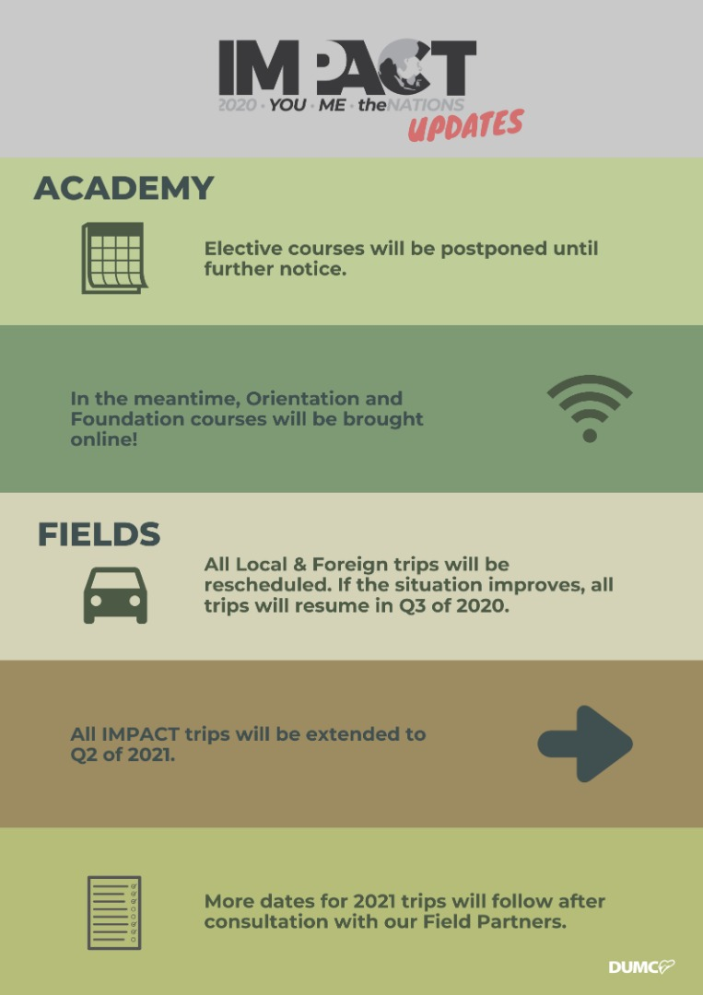

EQUIP COURSES 2020

Note: EQUIP sessions below will be conducted via an online platform and you are encouraged to log on early to familiarise yourself with the tool.

EVANGELISM 101
4 Apr | 8.30am-1.00pm | Online

BABY DEDICATION PREPARATION COURSE (BDPC)
4, 18 Apr | 11.30am-2.30pm | Online
Sign up at the info counter

BASIC CHRISTIANITY 101 (Membership Requirement)
25 Apr, 2 May | 8.30am-1.00pm | Online

DUMC 101 (Membership Requirement)
16 May | 8.30am-1.00pm | Online

SPIRITUAL WARFARE 201
30 May & 6 Jun | 8.30am-1.00pm | Online

CHRISTIAN LIVING 201
20, 27 Jun | 8.30am-1.00pm | Online

PRAYER 101
28 Jun- 23 Aug | 8.30am-9.30am | Online

Find out more about Equip courses online at http://dumc.my/equip

