CONTENTS

Worship
Word
Works
Upcoming:
Preaching Schedule
Event Highlights
IMPACT2020 (New)
Equip courses

WORSHIP (Praise and Prayer)

- Holy Week Prayer
What a strange paradox; the King is coming, the people rejoice, singing ‘Hosanna in the highest!’ yet fail to understand that the King they welcome is the Servant King, the King who washes his disciples’ feet, the King who came not with an army but a weapon so powerful that not even death could resist, the sacrificial love of God laid out upon a Cross.
Lord God, as we sing our ‘Hosannas’ today may we remember also that which you were riding toward; the suffering and rejection, pain and humiliation, the cruel Cross. And let us look forward to the joy of Easter Day, when you rose from death to reign forever. Help us, as we daily lay our lives before you, to live the resurrection life that acknowledges Jesus as Lord and King over our lives. – John Birch

- COVID-19
The coronavirus disease is still spreading rapidly around the world. As of noon of 3 Apr, >1 million people have been infected. Death toll is >53,000 people. At least 181 countries impacted. It is especially severe in the United States, Italy and Spain.
Pray for, and ask God for/to
DUMC Social Concerns Department and Charity Organisations
• Protection and strength – physically, mentally and emotionally • Wisdom to plan and manage their operations
• Multiplication of resources – funds, supplies, manpower
• Connection to the needy and in a timely manner
• Favour and support from the authorities
Families Adjusting to New Ways of Life
• Help families appreciate and enjoy everyone being home
• Guide people in their new realities
• Give spouses grace for each other
• Prompt worn-out parents to speak words of kindness and encouragement to their children • Help children find creative ways to experience God and continue learning
Business Owners and Families Facing Financial Stress
• Wisdom and grace for business owners to manage such unprecedented disruption to their businesses
• Provision for those in financial difficulty
• Aid to be made immediately to those who are dependent on daily wages, the poor, outcast, underprivileged, refugees, and undocumented
Grocery Store Workers & Delivery Drivers
• Good health and protection from contracting the new coronavirus
• Grace to handle disgruntled customers
• Journey mercy as they travel

WORD (60 Minutes)

- Read the scripture passage.
- Do a SUMMARY of the sermon highlighting the KEY POINTS. Do not preach the whole sermon, as majority of your members would have heard the sermon already. Allocate more time for sharing in the cell through the application questions below.
- Sermon Resource at: http://www.dumc.my/resources/sermons/

The Apostles’ Creed
(Matthew 3:16-17,Romans 8:14-17)
Senior Pastor Chris Kam

Big Idea: The Infinite God who invites me to Intimacy

Reflection & Application Questions:

1. Describe your concept of God as your heavenly Father. What issues with your human father continue to affect your concept of Him? (Don’t try to be hypothetical about how you should or could relate to God as Father. Think honestly about the way you view, respond to, and relate to Him.)

2. How does the knowledge of God being the Almighty Father and Creator, one who is intimately personal yet infinitely powerful, change the way you see and live your life? How does this also affect your thoughts and beliefs during this pandemic situation?

3. What do you appreciate about the concept of a Trinitarian God? In the Trinity, God is in constant and eternal relationship with himself as Father, Son and Holy Spirit. Love and community exist in the Trinity. Being made in God's image, share whether this period of undesired isolation has helped you appreciate God and community. What have you done to stay connected with the community God has given you in this period of MCO?

Note to Word facilitator:
As you are preparing for this session, this is a great time to pray that the Holy Spirit will guide you to use the questions efficaciously. You can select, modify or entirely create your own questions, according to the needs of your CG, especially if you feel that there are too many questions than required for the allocated time.

Note to Cell Groups that have children during meeting:
We recognise that several cell groups in DUMC may have 5 or more children joining them during Cell Group meetings. We would like to get them engaged as well during the session therefore we are suggesting for CGs to use Manna Pad and assign someone in rotation to facilitate them after worship. Here is the link to the Manna Pad materials http://dumc.my/resources/downloads/

WORKS (Ministry and Bearing Witness)

- Share Your Story – even during MCO! (Your Story, His Glory)
- Whether your story is about how you came to know Christ, illness healed, an act of kindness in your times of need, or of how you served people or how people have served you, give glory to God. Share your story so that people will be encouraged and God's love is known.
- If there are any good testimonies, ask your members to write out their testimonies and submit to the church: http://dumc.my/connect/individual-care/share-your-story/

- 2020 BIBLE READING PLAN (Lectio Divina: Stop, Listen, Go)
Savour Luke and Acts one chapter a week with daily bite-sized readings to meditate and pray on. Get your printed copy at the Info Counter. Info? Download a copy, visit dumc.my/brp

- CMS: Steps to Fill in the Salvation Form
- Select “More” 🡪 “Form”
- Select “Form List” box
- Look for “Salvation Form”
- Fill in form of new salvation by “Change Respondent”
- Must have “E-mail” and “Mobile Phone”

UPCOMING

PREACHING SCHEDULE

11&12 April | The Transforming Encounter Of Easter (live streaming only) | SP Chris Kam

Online live streaming via: dumc.my/watch-live at celebration timings on Sat@5pm and Sun@9am
Go to: http://www.dumc.my/resources/sermons/ for the latest info

EVENT HIGHLIGHTS

  - CELEBRATION VENUES (decentralised in the duration of MCO)
Saturdays | 5.00 pm | Meet at respective CG locations
Sundays | 9.00am | Meet at respective CG locations
Info? Email general@dumc.my

  - Join Celebrations in DUMC@Puchong every Sunday (except on weekends stated above)
Bring your friends and family members living around the Puchong area. Look for DUMC@Puchong on Waze or Google Maps. (Please park at IOI Business Park Level B2)

  - CHURCH PRAYER ALTAR (decentralised in the duration of MCO)
Every Saturday | 7.00 -9.00am | Hall 3
Let us come and seek the face of God. Prayer precedes everything.
Info? Contact forerunners@dumc.my

  - TUESDAY ENCOUNTER NIGHT (3rd & 4th Tuesdays of every month) (temporarily deferred)
Come together and be refreshed by His presence.
Info? Contact forerunners@dumc.my

  - Sign up for access to RightNow Media (from DUMC news)
Enter your particulars into this link: bit.ly/DUMC-RNM

  - WANT TO JOIN THE DUMC FAMILY?
Here are the steps:
> Join a Cell Group (You can get help at our CG Kiosk)
> Attend Basic Christianity 101
> Attend DUMC 101
> Join an Encounter Weekend
> Baptism & Membership Interview
Sign up at the Info Counter or online at dumc.my/equip

  - GOOD FRIDAY SERVICE 10 Apr | 8.00pm | Online
EASTER CELEBRATIONS 11 Apr | 5.00pm | Online / 12 Apr | 9.00am | Online
Online Let us commemorate the Passion of Jesus and celebrate His triumph over death! Join us at dumc.my/live

HIGHLIGHTSEVENT HIGHLIGHTS

IMPACT2020.YOU.ME.theNATIONS

IMPACT2020 has been launched for the English congregation on 29 Feb-1 Mar

What will happen because of the impact of COVID-19 (New)
    - IMPACT will extend for another six months into 2021
    - New revised one-stop link: dumc.my/IMPACT2020 for all your Academy and Field needs!
    - All information have been disseminated to your IMPACT Champions from your zone

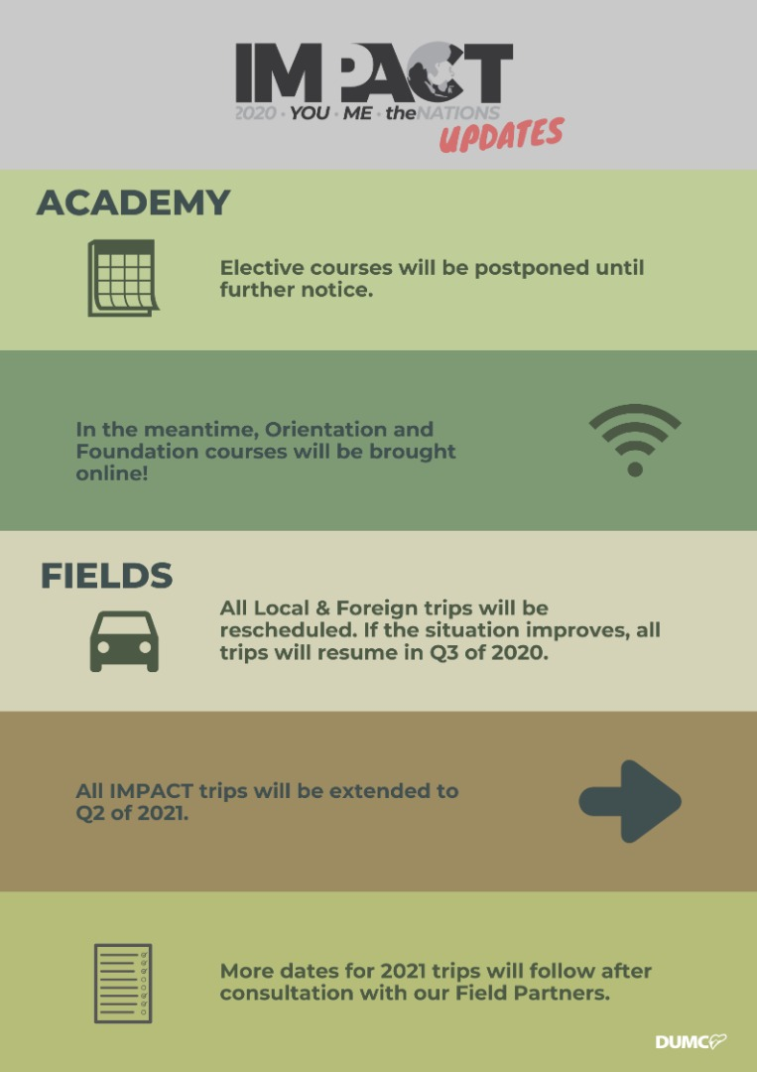

EQUIP COURSES 2020

Note: EQUIP sessions below will be conducted via an online platform and you are encouraged to log on early to familiarise yourself with the tool.

EVANGELISM 101
4 Apr | 8.30am-1.00pm | Online

BABY DEDICATION PREPARATION COURSE (BDPC)
4, 18 Apr | 11.30am-2.30pm | Online
Sign up at the info counter

BASIC CHRISTIANITY 101 (Membership Requirement)
25 Apr, 2 May | 8.30am-1.00pm | Online

DUMC 101 (Membership Requirement)
16 May | 8.30am-1.00pm | Online

SPIRITUAL WARFARE 201
30 May & 6 Jun | 8.30am-1.00pm | Online

CHRISTIAN LIVING 201
20, 27 Jun | 8.30am-1.00pm | Online

PRAYER 101
28 Jun- 23 Aug | 8.30am-9.30am | Online

Find out more about Equip courses online at http://dumc.my/equip

