CONTENTS

Worship
Word
Works
Upcoming:
Preaching Schedule
Event Highlights
IMPACT 2020 (New)
Equip courses

WORSHIP (Praise and Prayer)

- Easter Sunday 2020
This Easter sees the world in crisis, with deaths in every country from a virus that has ravaged the world unabated. This Easter, Christians will celebrate the hope of the resurrection because Jesus rose from the dead. Let us pray for the world with that hope in our hearts, that:
• Christians across the world will worship the Lord together in spirit, though separated from each other
• Christians will share the hope of an eternity beyond death and suffering, with those around them
• Those who are suffering in sorrow from loss, or in pain from disease may discover the Suffering Servant, Jesus Christ
- The Unsung Heroes on the Frontline
During this MO 'lockdown', let us pray for those who serve to save lives, protect us all and keep the machinery of our society and economy ticking over:
• Healthcare workers (doctors, nurses, Emits, lab technicians) who work long hours, in order that patients may get the treatment they need
• Enforcement officers ensuring compliance with the MO to curtail the spread of Coved-19
• Workers at the grocery stores and food outlets who continue to work to ensure essential supplies • Delivery workers (e.g. food, parcels) and truck drivers who maintain the supply chain, so that we can get the goods we need
- Global Mental Health Risk
With the global public health crisis and the resultant global economic shock, much of the world's economy will be impacted. With the prospects of business failures, the collapse of industries and significant unemployment, many people will come under enormous pressures mentally. Let us pray that:
• As governments work on combating the Coved-19 pandemic, and restoring the economy, they would establish and support initiatives by NGOs and mental health practitioners, to build support systems for the public
• Mental health advocates will collaborate to establish programmes to reach the people most needing mental health interventions
• Christian mental health practitioners will share the hope of eternal well-being as well to their clients

WORD (60 Minutes)

- Read the scripture passage.
- Do a SUMMARY of the sermon highlighting the KEY POINTS. Do not preach the whole sermon, as majority of your members would have heard the sermon already. Allocate more time for sharing in the cell through the application questions below.
- Sermon Resource at: http://www.dumc.my/resources/sermons/

The Unexpected Transforming Encounter with Jesus
(Luke 24:13-35)
Senior Pastor Chris Kam

Big Idea: “Christ has died. Christ has risen. Christ will come again.”

Reflection & Application Questions:

1. What are your thoughts and feelings about celebrating Easter during this MCO?

2. What are your thoughts and feelings about the potential economic impact post-COVID-19? What are your fears, concerns or hope?

3. How is your faith and understanding of who God is helping you during this period?

4. In what ways have the journey of the two disciples to Emmaus, and Jesus appearing incognito, helped you to understand and appreciate the Presence of Christ during this period? Were there situations in your life that you knew the Presence of Christ was there in your times of need? Please share.

5. In the light of Questions 1-4, you may wish to meditate on the following passage. In what ways does this passage help you?

(Hebrews 4:14-16)
14 Therefore, since we have a great high priest who has ascended into heaven, Jesus the Son of God, let us hold firmly to the faith we profess. 15 For we do not have a high priest who is unable to empathise with our weaknesses, but we have one who has been tempted in every way, just as we are—yet he did not sin. 16 Let us then approach God’s throne of grace with confidence, so that we may receive mercy and find grace to help us in our time of need.

Note to Word facilitator:
As you are preparing for this session, this is a great time to pray that the Holy Spirit will guide you to use the questions efficaciously. You can select, modify or entirely create your own questions, according to the needs of your CG, especially if you feel that there are too many questions than required for the allocated time.

Note to Cell Groups that have children during meeting:
We recognise that several cell groups in DUMC may have 5 or more children joining them during Cell Group meetings. We would like to get them engaged as well during the session therefore we are suggesting for CGs to use Manna Pad and assign someone in rotation to facilitate them after worship. Here is the link to the Manna Pad materials http://dumc.my/resources/downloads/

WORKS (Ministry and Bearing Witness)

- Share Your Story – even during MCO! (Your Story, His Glory)
- Whether your story is about how you came to know Christ, illness healed, an act of kindness in your times of need, or of how you served people or how people have served you, give glory to God. Share your story so that people will be encouraged and God's love is known.
- If there are any good testimonies, ask your members to write out their testimonies and submit to the church: http://dumc.my/connect/individual-care/share-your-story/

- 2020 BIBLE READING PLAN (Lectio Divina: Stop, Listen, Go)
Savour Luke and Acts one chapter a week with daily bite-sized readings to meditate and pray on. Get your printed copy at the Info Counter. Info? Download a copy, visit dumc.my/brp

- CMS: Steps to Fill in the Salvation Form
- Select “More” 🡪 “Form”
- Select “Form List” box
- Look for “Salvation Form”
- Fill in form of new salvation by “Change Respondent”
- Must have “E-mail” and “Mobile Phone”

UPCOMING

PREACHING SCHEDULE

18&19 April | The Apostles’ Creed 111 (live streaming only) | SP Chris Kam

Online live streaming via: dumc.my/watch-live at celebration timings on Sat@5pm and Sun@9am
Go to: http://www.dumc.my/resources/sermons/ for the latest info

EVENT HIGHLIGHTS

  - CELEBRATION VENUES (decentralised in the duration of MCO)
Saturdays | 5.00 pm | Meet at respective CG locations
Sundays | 9.00am | Meet at respective CG locations
Info? Email general@dumc.my

  - Join Celebrations in DUMC@Puchong every Sunday (except on weekends stated above)
Bring your friends and family members living around the Puchong area. Look for DUMC@Puchong on Waze or Google Maps. (Please park at IOI Business Park Level B2)

  - CHURCH PRAYER ALTAR (decentralised in the duration of MCO)
Every Saturday | 7.00 -9.00am | Hall 3
Let us come and seek the face of God. Prayer precedes everything.
Info? Contact forerunners@dumc.my

  - TUESDAY ENCOUNTER NIGHT (3rd & 4th Tuesdays of every month) (temporarily deferred)
Come together and be refreshed by His presence.
Info? Contact forerunners@dumc.my

  - Sign up for access to RightNow Media (from DUMC news)
Enter your particulars into this link: bit.ly/DUMC-RNM

  - WANT TO JOIN THE DUMC FAMILY?
Here are the steps:
> Join a Cell Group (You can get help at our CG Kiosk)
> Attend Basic Christianity 101
> Attend DUMC 101
> Join an Encounter Weekend
> Baptism & Membership Interview
Sign up at the Info Counter or online at dumc.my/equip

  - DUMC SOCIAL CONCERNS DEPARTMENT (SCD)
In this challenging time, our SCD is offering assistance, relief & aid to affected communities. For help, call our Help Desk: 016 918 9968 or email marianne.tsen@dumc.my
To donate: dumc.my/give

  - MENALIVE HUDDLE
9 May | 9.00am-11.30am | Zoom
Topic: A Biblical Definition of Manhood, Part 1 Exclusively for men.
Info? Visit fb.com/MenAliveDUMC

HIGHLIGHTSEVENT HIGHLIGHTS

IMPACT2020.YOU.ME.theNATIONS

IMPACT2020 has been launched for the English congregation on 29 Feb-1 Mar

What will happen because of the impact of COVID-19 (New)
    - IMPACT will extend for another six months into 2021
    - New revised one-stop link: dumc.my/IMPACT2020 for all your Academy and Field needs!
    - All information have been disseminated to your IMPACT Champions from your zone

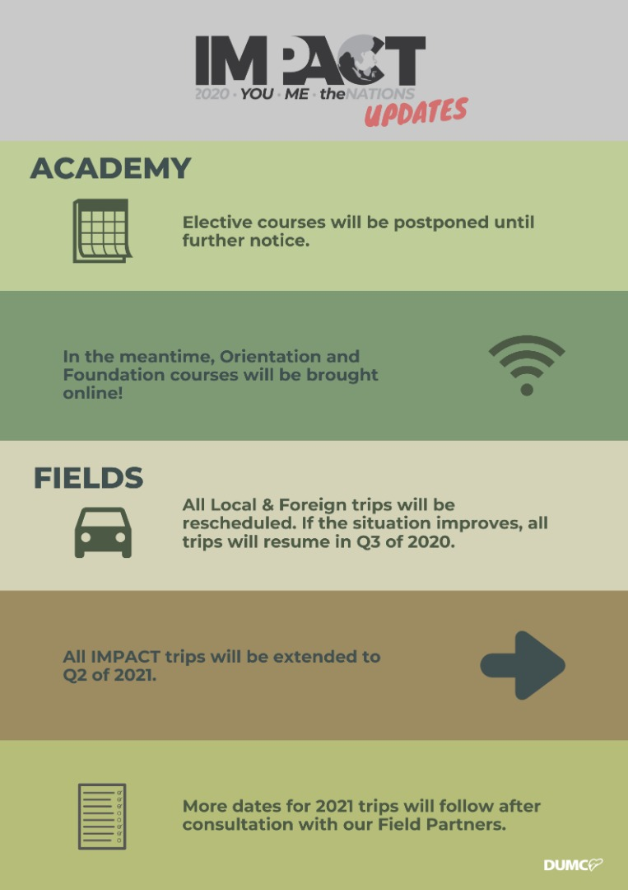

EQUIP COURSES 2020

Note: EQUIP sessions below will be conducted via an online platform and you are encouraged to log on early to familiarise yourself with the tool.

EVANGELISM 101
4 Apr | 8.30am-1.00pm | Online

BABY DEDICATION PREPARATION COURSE (BDPC)
4, 18 Apr | 11.30am-2.30pm | Online
Sign up at the info counter

BASIC CHRISTIANITY 101 (Membership Requirement)
25 Apr, 2 May | 8.30am-1.00pm | Online

DUMC 101 (Membership Requirement)
16 May | 8.30am-1.00pm | Online

SPIRITUAL WARFARE 201
30 May & 6 Jun | 8.30am-1.00pm | Online

CHRISTIAN LIVING 201
20, 27 Jun | 8.30am-1.00pm | Online

PRAYER 101
28 Jun- 23 Aug | 8.30am-9.30am | Online

Find out more about Equip courses online at http://dumc.my/equip

