CONTENTS

Worship
Word
Works
Upcoming:
Preaching Schedule
Event Highlights
IMPACT 2020 (New)
Equip courses

WORSHIP (Praise and Prayer)

While we cannot move around freely in this season of the Movement Control Order, we can continue to pray unceasingly in adoration and praise as we remember the grace of the Risen Saviour in difficult times.

- Pray For Self
Read Romans 8:37-39
Lord Jesus, help me see You as the risen and triumphant One and to recognise Your presence during this time of isolation. Help me not to waste this precious time of quiet so that I can draw closer to You by immersing myself in Your Word and listening to Your still small voice. Strengthen me in the spirit, and in knowing that Your grace is sufficient for me. Thank You that nothing will separate me from Your love. Amen.
- Pray For A Miracle For The Sick And Those Afflicted By The Virus
Read Isaiah 53:4-5
Abba Father, You have done great things, and continue to do great things. Even when we don’t see it, You never stop working. You are sovereign and in control. You see the suffering and the sickness, the deaths and the brokenness. We want to see Your name lifted high and glorified. Our hearts‘ desire is to testify to the power of the cross and bring glory to You, O Lord Jesus, who raise the dead to live again, lead the sick to walk out of the ICU, and open the doors of hospitals with joy as patients are being discharged, with homes filled with laughter, and the virus contained. As You rebuked the storm to be still, rebuke also the virus to be still and submit to the power of Your mighty name. Amen.
- Pray For The Anxious
Read 1 Peter 5:7
Dear God, please take away the fear and anxiety and replace that with the peace that passes understanding. Please comfort them with Your presence and Your love, and give them a heart of thanksgiving, purpose and joy this Sunday. In Jesus’ mighty name we pray, Amen.
- Pray For The Elderly And The Infirmed/Vulnerable
Read Psalm 46:1
Lord God, we pray for our elderly parents, grandparents, friends and neighbours who are vulnerable and infirmed. Would You protect them from the coronavirus infection and heal them of their underlying illnesses. Please help us to be salt and light at such times and reach out to them that they may be able to experience Your love and comfort through our lips, hands and feet. Amen.

WORD (60 Minutes)

- Read the scripture passage.
- Do a SUMMARY of the sermon highlighting the KEY POINTS. Do not preach the whole sermon, as majority of your members would have heard the sermon already. Allocate more time for sharing in the cell through the application questions below.
- Sermon Resource at: http://www.dumc.my/resources/sermons/

The Apostles’ Creed 111
(Matthew 16:13-16; Hebrews 1:3; Romans 10:9)
Senior Pastor Chris Kam

Big Idea: “Jesus the Christ, the Son, our Lord”.

Reflection & Application Questions:

1. What is the Holy Spirit saying to you in this sermon? What are some of your personal thoughts and impressions about your relationship with Jesus?

2. Discuss this phrase in the light of “Jesus the Christ” and what it means: “We lost it all. He did it all. We gain it all.”

3. Discuss C.S. Lewis’ Trilemma; what does it mean to you personally? How can you use this as an apologetic approach to your pre-believing friends?

4. Discuss Luke 6:46 “Why do you call me, ‘Lord, Lord,’ and do not do what I say?” Have your lifestyle and values reflected the Lordship of Christ? Why or why not? It is a good point to spend some time here reflecting and even repenting where necessary. How can you reflect the Lordship of Christ more in your life? What are some areas that need to be surrendered to Christ?

THE APOSTLES’ CREED

I Believe in God, the Father Almighty,
Creator of heaven and earth,
I Believe in Jesus Christ, His Only Son, our Lord,
who was conceived by the Holy Spirit,
born of the Virgin Mary,
suffered under Pontius Pilate,
was crucified, died, and was buried;
the third day He rose again from the dead.
He ascended into heaven,
is seated at the right hand of the Father,
and will come again to judge the living and the dead.
I Believe in The Holy Spirit,
the holy catholic* church,
the communion of saints,
the forgiveness of sins,
the resurrection of the body,
and the life everlasting.
Amen.

Note to Word facilitator:
As you are preparing for this session, this is a great time to pray that the Holy Spirit will guide you to use the questions efficaciously. You can select, modify or entirely create your own questions, according to the needs of your CG, especially if you feel that there are too many questions than required for the allocated time.

Note to Cell Groups that have children during meeting:
We recognise that several cell groups in DUMC may have 5 or more children joining them during Cell Group meetings. We would like to get them engaged as well during the session therefore we are suggesting for CGs to use Manna Pad and assign someone in rotation to facilitate them after worship. Here is the link to the Manna Pad materials http://dumc.my/resources/downloads/

WORKS (Ministry and Bearing Witness)

- Share Your Story – even during MCO! (Your Story, His Glory)
- Whether your story is about how you came to know Christ, illness healed, an act of kindness in your times of need, or of how you served people or how people have served you, give glory to God. Share your story so that people will be encouraged and God's love is known.
- If there are any good testimonies, ask your members to write out their testimonies and submit to the church: http://dumc.my/connect/individual-care/share-your-story/

- 2020 BIBLE READING PLAN (Lectio Divina: Stop, Listen, Go)
Savour Luke and Acts one chapter a week with daily bite-sized readings to meditate and pray on. Get your printed copy at the Info Counter. Info? Download a copy, visit dumc.my/brp

- CMS: Steps to Fill in the Salvation Form
- Select “More” 🡪 “Form”
- Select “Form List” box
- Look for “Salvation Form”
- Fill in form of new salvation by “Change Respondent”
- Must have “E-mail” and “Mobile Phone”

UPCOMING

PREACHING SCHEDULE

25&26 April | The Apostles’ Creed IV (live streaming only) | Pr Mike Ngui

Online live streaming via: dumc.my/watch-live at celebration timings on Sat@5pm and Sun@9am
Go to: http://www.dumc.my/resources/sermons/ for the latest info

EVENT HIGHLIGHTS

  - CELEBRATION VENUES (decentralised in the duration of MCO)
Saturdays | 5.00 pm | Meet at respective CG locations
Sundays | 9.00am | Meet at respective CG locations
Info? Email general@dumc.my

  - Join Celebrations in DUMC@Puchong every Sunday (except on weekends stated above)
Bring your friends and family members living around the Puchong area. Look for DUMC@Puchong on Waze or Google Maps. (Please park at IOI Business Park Level B2)

  - CHURCH PRAYER ALTAR (decentralised in the duration of MCO)
Every Saturday | 7.00 -9.00am | Hall 3
Let us come and seek the face of God. Prayer precedes everything.
Info? Contact forerunners@dumc.my

  - TUESDAY ENCOUNTER NIGHT (3rd & 4th Tuesdays of every month) (temporarily deferred)
Come together and be refreshed by His presence.
Info? Contact forerunners@dumc.my

  - Sign up for access to RightNow Media (from DUMC news)
Enter your particulars into this link: bit.ly/DUMC-RNM

  - WANT TO JOIN THE DUMC FAMILY?
Here are the steps:
> Join a Cell Group (You can get help at our CG Kiosk)
> Attend Basic Christianity 101
> Attend DUMC 101
> Join an Encounter Weekend
> Baptism & Membership Interview
Sign up at the Info Counter or online at dumc.my/equip

  - DUMC SOCIAL CONCERNS DEPARTMENT (SCD)
In this challenging time, our SCD is offering assistance, relief & aid to affected communities. For help, call our Help Desk: 016 918 9968 or email marianne.tsen@dumc.my
To donate: dumc.my/give

  - MENALIVE HUDDLE
9 May | 9.00am-11.30am | Zoom
Topic: A Biblical Definition of Manhood, Part 1 Exclusively for men.
Info? Visit fb.com/MenAliveDUMC

  - WEEKDAY MESSAGE FROM OUR SENIOR PASTOR
Released on weekdays around 8.00pm. Watch the updates & short devotions together as a family.
View at bit.ly/SPdailyMsg

HIGHLIGHTSEVENT HIGHLIGHTS

IMPACT2020.YOU.ME.theNATIONS

IMPACT2020 has been launched for the English congregation on 29 Feb-1 Mar

What will happen because of the impact of COVID-19 (New)
    - IMPACT will extend for another six months into 2021
    - New revised one-stop link: dumc.my/IMPACT2020 for all your Academy and Field needs!
    - All information have been disseminated to your IMPACT Champions from your zone

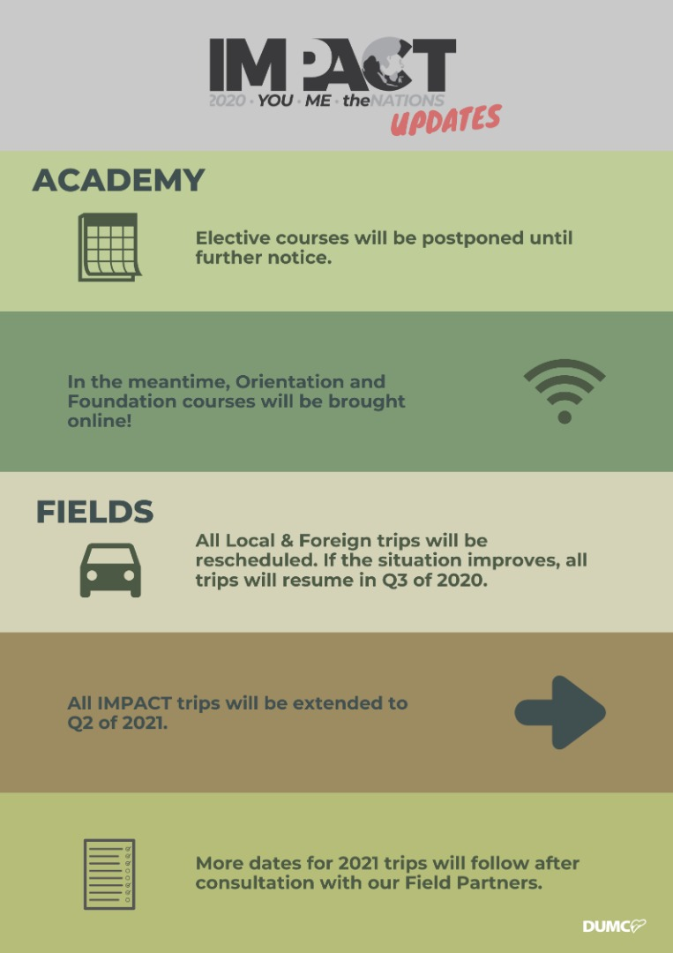

EQUIP COURSES 2020

Note: EQUIP sessions below will be conducted via an online platform and you are encouraged to log on early to familiarise yourself with the tool.

EVANGELISM 101
4 Apr | 8.30am-1.00pm | Online

BABY DEDICATION PREPARATION COURSE (BDPC)
4, 18 Apr | 11.30am-2.30pm | Online
Sign up at the info counter

BASIC CHRISTIANITY 101 (Membership Requirement)
25 Apr, 2 May | 8.30am-1.00pm | Online

DUMC 101 (Membership Requirement)
16 May | 8.30am-1.00pm | Online

SPIRITUAL WARFARE 201
30 May & 6 Jun | 8.30am-1.00pm | Online

CHRISTIAN LIVING 201
20, 27 Jun | 8.30am-1.00pm | Online

PRAYER 101
28 Jun- 23 Aug | 8.30am-9.30am | Online

Find out more about Equip courses online at http://dumc.my/equip

