CONTENTS

Worship
Word
Works
Upcoming:
Preaching Schedule
Event Highlights
IMPACT2020 (New)
Equip courses

WORSHIP (Praise and Prayer)

COVID-19
Let us continue to pray for our nation and the rest of the world as we battle this common enemy in Covid-19.

- Pray For Rulers,Politicans,National Leaders And Civil Servants
1 Timothy 2:1-2 NIV
"I urge, then, first of all, that petitions, prayers, intercession and thanksgiving be made for all people—for kings and all those in authority, that we may live peaceful and quiet lives in all godliness and holiness."
Lord God, we cast aside our political leanings, and ask that You give national leaders wisdom and humility as they make crucial decisions preparing for easing of restrictions. Surround them with good advisors and able civil servants to execute correctly such plans. We pray that You will lead them to determine the right steps at the right time so that the people of our nation (and other nations in the world) may be blessed. By the power of Jesus’ name, Amen.
- Pray For Those Affected Financially
Philippians 4:19 NIV
"And my God will meet all your needs according to the riches of his glory in Christ Jesus."

Gracious Heavenly Father, You are the one we turn to for our daily needs. Many families and businesses are suffering from loss of income during this lockdown, and are deeply anxious as to whether they can find jobs after the restrictions are relaxed. Many employers are deeply in debt and may be unable to offer jobs as their businesses have been hurt. Many migrant and refugee communities are badly affected. So we ask that You will intervene and help these businesses to be rebuild and be restored. Again, we ask that You will help us be Your hands and feet and be generous at such times so that people may know and experience Your amazing grace. Amen.

3.) Pray For Healthcare /Frontline Care &Service Professionals/Providers
Isaiah 58:10 NIV
"...if you spend yourselves in behalf of the hungry and satisfy the needs of the oppressed, then your light will rise in the darkness, and your night will become like the noonday."
Lord God, we thank You for the encouraging results from the recent lockdowns. We continue to ask for Your protection and encouragement for all the health workers and front liners as they see less number of cases and more discharged patients recovering from the virus each day. We pray that You will give them peace, wisdom, and strength, and protect them and their families from infection. Amen.
WORD (60 Minutes)

- Read the scripture passage.
- Do a SUMMARY of the sermon highlighting the KEY POINTS. Do not preach the whole sermon, as majority of your members would have heard the sermon already. Allocate more time for sharing in the cell through the application questions below.
- Sermon Resource at: http://www.dumc.my/resources/sermons/

The Apostles’ Creed IV
(Philippians 2:6-8)
Pastor Mike Ngui
Big Idea: Jesus lived and died in obedience to the Father, for our sake.

Reflection & Application Questions:

1. We often hear the saying, “Jesus is Lord of all or not at all”. Is Jesus fully Lord over your life? If not, what are aspects of your life that you need to work on surrendering to HIM?

2. The crucifixion is foolishness for the Greeks and even offends some .How does the crucifixion make you feel?

3. Knowing that Jesus was 100% man and lived His life as a human ,how does that help you to relate to Jesus? Also knowing that He did not sin ,but obeyed the Father in everything ,how does that make you want to live your life ?

Note to Word facilitator:
As you are preparing for this session, this is a great time to pray that the Holy Spirit will guide you to use the questions efficaciously. You can select, modify or entirely create your own questions, according to the needs of your CG, especially if you feel that there are too many questions than required for the allocated time.

Note to Cell Groups that have children during meeting:
We recognise that several cell groups in DUMC may have 5 or more children joining them during Cell Group meetings. We would like to get them engaged as well during the session therefore we are suggesting for CGs to use Manna Pad and assign someone in rotation to facilitate them after worship. Here is the link to the Manna Pad materials http://dumc.my/resources/downloads/

WORKS (Ministry and Bearing Witness)

- Share Your Story – even during MCO! (Your Story, His Glory)
- Whether your story is about how you came to know Christ, illness healed, an act of kindness in your times of need, or of how you served people or how people have served you, give glory to God. Share your story so that people will be encouraged and God's love is known.
- If there are any good testimonies, ask your members to write out their testimonies and submit to the church: http://dumc.my/connect/individual-care/share-your-story/

- 2020 BIBLE READING PLAN (Lectio Divina: Stop, Listen, Go)
Savour Luke and Acts one chapter a week with daily bite-sized readings to meditate and pray on. Get your printed copy at the Info Counter. Info? Download a copy, visit dumc.my/brp

- CMS: Steps to Fill in the Salvation Form
- Select “More” 🡪 “Form”
- Select “Form List” box
- Look for “Salvation Form”
- Fill in form of new salvation by “Change Respondent”
- Must have “E-mail” and “Mobile Phone”

UPCOMING

PREACHING SCHEDULE

2&3 May 2020 | The Apostles ‘ Creed V (live streaming only) | Pr Mike Ngui

Online live streaming via: dumc.my/watch-live at celebration timings on Sat@5pm and Sun@9am
Go to: http://www.dumc.my/resources/sermons/ for the latest info

EVENT HIGHLIGHTS

  - CELEBRATION VENUES (decentralised in the duration of MCO)
Saturdays | 5.00 pm | Meet at respective CG locations
Sundays | 9.00am | Meet at respective CG locations
Info? Email general@dumc.my

  - Join Celebrations in DUMC@Puchong every Sunday (except on weekends stated above)
Bring your friends and family members living around the Puchong area. Look for DUMC@Puchong on Waze or Google Maps. (Please park at IOI Business Park Level B2)

  - CHURCH PRAYER ALTAR (decentralised in the duration of MCO)
Every Saturday | 7.00 -9.00am | Hall 3
Let us come and seek the face of God. Prayer precedes everything.
Info? Contact forerunners@dumc.my

  - TUESDAY ENCOUNTER NIGHT (3rd & 4th Tuesdays of every month) (temporarily deferred)
Come together and be refreshed by His presence.
Info? Contact forerunners@dumc.my

  - Sign up for access to RightNow Media (from DUMC news)
Enter your particulars into this link: bit.ly/DUMC-RNM

  - WANT TO JOIN THE DUMC FAMILY?
Here are the steps:
> Join a Cell Group (You can get help at our CG Kiosk)
> Attend Basic Christianity 101
> Attend DUMC 101
> Join an Encounter Weekend
> Baptism & Membership Interview
Sign up at the Info Counter or online at dumc.my/equip

  - MESSAGE FROM OUR SENIOR PASTOR
Released on weekdays around 8.00pm. Watch the updates & short devotions together as a family.
View at bit.ly/SpdailyMsg

  - CROSSFIELDS PRAYER MEETING
2 May | 9:00-11.00am | Zoom
A prayer for the nations. Register at bit.ly/MPMregistration
Our next meeting is on 6 June 2020.

HIGHLIGHTSEVENT HIGHLIGHTS

IMPACT2020.YOU.ME.theNATIONS

IMPACT2020 has been launched for the English congregation on 29 Feb-1 Mar

What will happen because of the impact of COVID-19 (New)
    - IMPACT will extend for another six months into 2021
    - New revised one-stop link: dumc.my/IMPACT2020 for all your Academy and Field needs!
    - All information have been disseminated to your IMPACT Champions from your zone

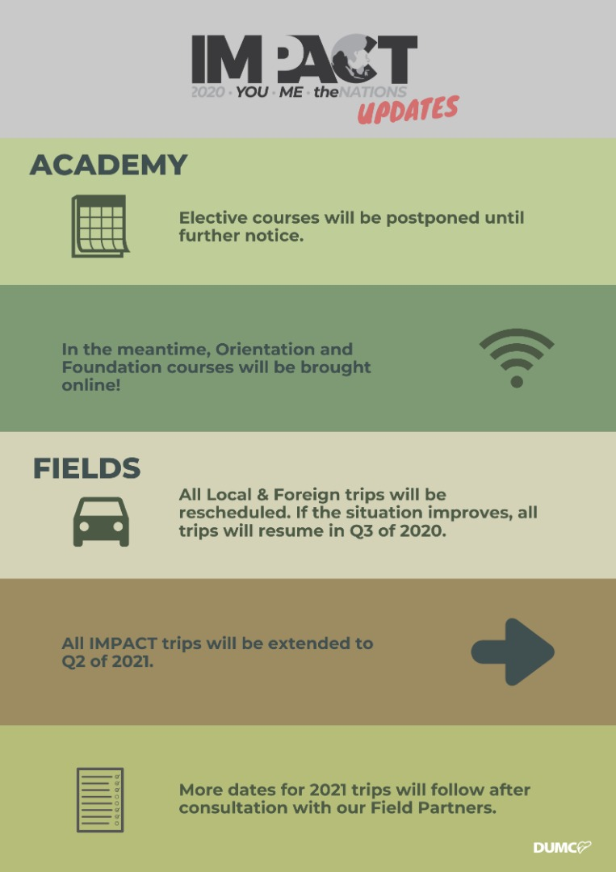

EQUIP COURSES 2020

Note: EQUIP sessions below will be conducted via an online platform and you are encouraged to log on early to familiarise yourself with the tool.

EVANGELISM 101
4 Apr | 8.30am-1.00pm | Online

BABY DEDICATION PREPARATION COURSE (BDPC)
2&23 May| 11.30am-2.30pm | Online
Sign up at the info counter

BASIC CHRISTIANITY 101 (Membership Requirement)
25 Apr, 2 May | 8.30am-1.00pm | Online

DUMC 101 (Membership Requirement)
16 May | 8.30am-1.00pm | Online

SPIRITUAL WARFARE 201
30 May & 6 Jun | 8.30am-1.00pm | Online

CHRISTIAN LIVING 201
20, 27 Jun | 8.30am-1.00pm | Online

PRAYER 101
28 Jun- 23 Aug | 8.30am-9.30am | Online

SPIRITUAL RETREAT - TURNING TO GOD IN UNCERTAIN TIMES
7 May | 10.00am-11.00am | Online
& 16 May | 10.30am-12.00pm | Online
Sign up at bit.ly/SRO_May

Find out more about Equip courses online at http://dumc.my/equip

